The Clinical Attention Framework: Confounder-Aware Routing for Multimodal Medical AI

Authors: Mustafa Nassar*, Anas Aburaya, Sophio Samkharadze, Osama Abdelhay, Maia Mujiri, Eka Kokheirdze, Lanad Lursmanashvili, Deya Abushariha, Ahmed Baker
Affiliations:
Department of Dentistry, European University, 76 David Guramishvili Ave, Tbilisi 0141, Georgia.
Department of Data Science and Artificial Intelligence, Princess Sumaya University for Technology, Amman, Jordan
*Corresponding Author: Mustafa Nassar/ Gldani, Tbilisi, 0141, Georgia / Email: mustafanassar2003@gmail.com, Phone number: +995599994605

Abstract
Multimodal deep learning has shown immense promise in clinical decision support systems. However, traditional fusion architectures rely on static feature concatenation or rigid attention mechanisms. These approaches are highly vulnerable to conflicting modalities, where one input channel presents deceptive signals due to biological confounders. In this paper, we introduce the Clinical Attention Framework (CAF), a novel gated multimodal architecture that uses external clinical context to dynamically route diagnostic trust. To validate our framework, we present a biological proof-of-concept using a cohort of $N=46$ patients, evaluating “The Nicotine-Induced Diagnostic Mismatch” in periodontics. In active vapers, nicotine-induced vasoconstriction masks visible clinical signs of soft-tissue inflammation (bleeding and redness), presenting a deceptive visual signal. The CAF dynamically evaluates the patient’s vaping status to route attention weights ($P_{soft}$ for clinical photos, $P_{hard}$ for radiographs, and $P_{tab}$ for questionnaires), suppressing the confounded visual modality and relying on objective clinical measurements. Our framework achieves superior diagnostic performance ($68.59\%±1.52\%$ accuracy, $0.7013±0.0227$ ROC-AUC) and exhibits emergent, deductive clinical reasoning without explicit modality supervision. Finally, we demonstrate that the CAF’s gating mechanism is domain-agnostic, offering a generalizable blueprint to resolve physiological masking effects across broader clinical domains.

1. Introduction
While clinical decision-making requires dynamic, multi-source data integration, current deep learning models struggle to mimic this reasoning (Das & Akter, 2025; Fan et al., 2024). A critical vulnerability in existing pipelines is their reliance on rigid architectures and static feature concatenation, which inherently fail to adapt when a modality loses its diagnostic relevance. (Fan et al., 2024). This exposes a critical vulnerability to "Conflicting Modalities" (Fan et al., 2024). A "Diagnostic Mismatch" occurs when intrinsic noise creates discrepancies between data streams, conflicting modalities, and current AI fails catastrophically; if one modality sends a deceptive signal that contradicts the others, the system cannot adaptively reduce its reliance on the flawed data, resulting in a severe decline in diagnostic accuracy (Fan et al., 2024; Jandoubi & Akhloufi, 2025)
Most current multimodal deep learning pipelines execute early, late, or intermediate fusion operations without strong theoretical foundations regarding the complex, dynamic relationships between modalities (Jandoubi & Akhloufi,2025). These traditional methods typically rely on the simple concatenation of latent features and utilize static weights, which mathematically optimizes for the average patient but fundamentally limits the model's ability to adapt when diagnostic reliability fluctuates in specific subgroups. (Fan et al., 2024). This rigid architectural flaw fundamentally exacerbates the widely recognized "Black Box" problem in medical artificial intelligence (Otieno & Oluoch, 2026; Das & Akter, 2025). Because late and early fusion models use these static weights rather than adaptive, context-aware mechanisms, they cannot provide the transparent, causal explainability (XAI) required to build clinical trust, satisfy regulatory standards, and ensure patient safety (Otieno & Oluoch, 2026; Luke, 2024; Fan et al., 2024).
While cross-modal attention networks attempt to map correlations across heterogeneous data streams, these standards "data-driven" mechanisms frequently fail in clinical settings. Without clinical constraints, they are highly susceptible to "shortcut learning," often fixating on dataset-specific artifacts or irrelevant borders rather than genuine pathology (Otieno & Oluoch, 2026; Dyrba et al., 2020). This purely statistical approach becomes a critical liability during active biological conflicts, as standard attention lacks the contextual awareness to identify and resolve deceptive signals or intrinsic noise (Fan et al., 2024; Otieno & Oluoch, 2026). To overcome this gap, our architecture implements a confounder-aware gating mechanism. Unlike standard cross-modal attention, which cannot resolve these conflicts, a Confounder-Driven mechanism uses external clinical context to dynamically "distrust" and down-weight any modality sending a contradictory signal. This adaptively resolves the diagnostic mismatches that cause traditional data-driven models to fail.
To validate our architecture, we introduce a periodontal cohort of e-cigarette users as a rigorous biological proof-of-concept. In these patients, nicotine-induced vasoconstriction creates a " The Nicotine-Induced Diagnostic Mismatch"—a known, physiologically grounded masking effect that suppresses visible clinical signs of gingival inflammation, such as bleeding and redness, despite underlying tissue destruction (Figueredo et al., 2021; Silva, 2021). To navigate this biological deception, the Clinical Attention Framework (CAF) introduces a mechanism of "Dynamic Reliability Routing".
Rather than blindly seeking cross-modal statistical correlations, the CAF evaluates the external clinical confounder (the patient's vaping profile) to generate mathematically interpretable attention probabilities, specifically Psoft​ for clinical photos and Phard​ for radiographs. This directly mimics deductive clinical reasoning: if the framework detects a heavy vaping history, it dynamically routes diagnostic trust away from the deceptive soft-tissue modality (driving Psoft​ toward zero). It heavily weights the objective hard-tissue X-rays (elevating Phard​). By explicitly quantifying modality reliability, the CAF successfully bypasses physiological masking effects that cause traditional, static models to fail.
Current multimodal AI frequently exhibits "illusory generalizability," failing in real-world settings due to "shortcut learning" and the rigid assumption that modality reliability remains constant (Otieno & Oluoch, 2026; Fan et al., 2024). This creates a systemic, pan-medical bottleneck when biological confounders introduce deceptive signals. For example, in oncology, targeted therapies actively alter imaging phenotypes, confounding standard radiographic endpoints by inducing pseudoresponses that mask true tumor progression (Wen et al., 2010; Brandsma & van den Bent, 2009). Similarly, in cardiology, medications like beta-blockers mask physiological stress and significantly reduce the sensitivity of ischemic ST-segment responses on ECG readouts (Herbert et al., 1991). Traditional 'black box' AI networks struggle to maintain accuracy when faced with such patient-level comorbidities and therapeutic confounders (Elantary & Othman, 2025), highlighting the need for architectures that can actively route diagnostic trust.
To address this critical vulnerability, this paper introduces the Clinical Attention Framework (CAF). Designed as a domain-agnostic safeguard, the CAF's Conflict-Resolution Gate uses external clinical context to adaptively down-weight deceptive signals. Our core contributions establish a foundation for advancing multimodal diagnostics. Primarily, we present a novel gated multimodal architecture that generates transparent, mathematically interpretable attention weights, helping to mitigate the traditional "black box" limitations of fusion pipelines by enhancing interpretability. Furthermore, through our periodontal biological proof-of-concept, we provide initial empirical evidence on a micro-cohort demonstrating that the CAF’s attention gating engine can exhibit patterns consistent with deductive clinical reasoning, without requiring modality-specific supervision. Ultimately, we propose the CAF as a modular, domain-agnostic blueprint; while our current validation is bounded by a limited clinical cohort, the architecture is designed to be scalable, offering a foundational pathway toward out-of-distribution generalizability for diverse, broad-scale medical domains.

2. Materials and Methods

2.1 Patient Cohort and Clinical Protocol

2.1.1 Participant Selection and Inclusion Criteria

This single-center, cross-sectional observational pilot study was conducted at the European University Dental Clinic in Tbilisi, Georgia, from September 2025 to March 2026. The study protocol was formally approved by the Institutional Review Board (IRB) of European University, executed in strict compliance with the Declaration of Helsinki (“World Medical Association Declaration of Helsinki,” 2013), and utilized a robust data anonymization procedure alongside mandatory written informed consent from all participants. The study population comprised N = 46 systemically healthy participants aged 18 to 25 years, balanced symmetrically into 23 healthy individuals (Label 0) and 23 diseased individuals (Label 1). This cohort was partitioned into two strictly age- and gender-matched groups: Cohort 1 (n1 = 22 active electronic nicotine delivery systems [ENDS] users) and Cohort 2 (n2 = 24 non-vaping controls). For Cohort 1, variations in vaping history, duration, and habits were documented as continuous metadata variables rather than rigid binary cuts to preserve a real-world exposure spectrum, while Cohort 2 was restricted exclusively to individuals with absolute lifetime abstinence from all tobacco, electronic aerosols, and systemic nicotine variations. To isolate clear tissue interactions, all participants were required to have no history of systemic antibiotics within the last 3 months or professional periodontal treatment within the last 6 months. Individuals were excluded if they presented with systemic diseases (e.g., diabetes or autoimmune conditions), pregnancy, or current medications affecting gingival tissues (e.g., calcium channel blockers, phenytoin, cyclosporine). Dual-users of combined combustible tobacco and vaping were also excluded, alongside any cases presenting with insufficient data or missing modalities. Clinical diagnostic criteria aligned strictly with the 2017 World Workshop classification, where plaque-induced gingivitis was defined as Bleeding on Probing (BOP) exceeding 10% of sites with a Probing Pocket Depth (PPD) ≤ 3 mm and an absolute absence of radiographic bone loss (Papapanou et al., 2018). This structured cohort provided the core matrix for subsequent computational modeling and dynamic attention routing verification.

2.1.2 Multimodal Data Acquisition Protocol

All three modalities were acquired during a single standardized clinical visit by a single calibrated examiner (M.N.) to minimize inter-operator variability.

• Soft-Tissue Modality (Psoft): Intraoral clinical photography was performed using a Canon EOS 4000D equipped with a 100mm macro lens and twin flash system, calibrated to approximately 5500K color temperature. A standardized exposure protocol was applied across all patients (f/22, 1/200s, ISO 100) to ensure consistent color rendition and depth of field. Bilateral cheek retractors were used for each side, and the patient’s head position was standardized throughout. A full-mouth photographic series of 11 images per patient was acquired, capturing all relevant soft-tissue regions for subsequent inflammatory scoring.

• Hard-Tissue Modality (Phard): Hard-tissue assessment was performed using panoramic radiography via Rotational Slit-Beam Tomography on conventional film. Full-mouth radiographic coverage was obtained for all patients. Radiographic features extracted included bone crest levels and relevant hard-tissue morphological findings. All radiographs were independently evaluated by three expert clinicians to ensure diagnostic reliability.

• Questionnaire (Ptab): Prior to clinical examination, each participant completed a standardized 45-item paper-based questionnaire covering five domains: demographic characteristics, vaping and nicotine habits, oral hygiene practices, lifestyle factors, and self-reported periodontal symptoms. Paper administration before examination ensured responses were independent of clinical findings and examiner influence.

• Data Recording and Anonymization: All acquired data were stored on a password-protected, encrypted computer accessible exclusively to the principal investigators (M.N. and A.A.). Patient identifiers were removed at the point of data entry and replaced with anonymous numerical codes, ensuring no personally identifiable information was retained within the dataset. All procedures were conducted in full compliance with institutional data protection protocols and the Declaration of Helsinki.

2.2 Data Preprocessing and Modality Alignment
2.2.1 Soft-Tissue Continuous Intensity Indexing
Given the micro-cohort scale of the present dataset, deploying high-dimensional deep learning encoders such as convolutional neural networks would introduce severe dimensionality and overfitting risks. Instead, a continuous 1–10 Soft-Tissue Intensity Index was developed, adapted from the validated Lobene Modified Gingival Index (MGI) (Lobene et al., 1986). While the original MGI operates on a 0–4 ordinal scale, its coarse granularity is insufficient for machine learning applications requiring continuous, fine-grained feature discrimination. The expanded 1–10 scale preserves the clinical logic of the MGI while providing the numerical resolution necessary for gradient-based optimization and meaningful inter-patient differentiation.
The index explicitly measures surface tissue characteristics observable in standardized clinical photography and does not attempt to derive dimensional or volumetric measurements from two-dimensional photographic data. Scores reflect six observable tissue properties: gingival color and erythema intensity, marginal contour, surface texture, edema severity, glazing, and spontaneous hemorrhagic tendency.
Three independent expert clinicians, blinded to patient vaping status and to each other's scores, independently assigned index values to each patient's photographic series. Final scores were computed as the mean of the three independent ratings. Inter-rater reliability was assessed and is reported in Section 2.2.4.

2.2.2 Structural Radiographic Scaling
Parallel to the soft-tissue indexing approach, panoramic radiographs were converted into a continuous 1.0–10.0 Radiographic Severity Index to ensure architectural consistency across all modalities and eliminate dimensional incompatibility within the feature fusion pipeline. The scale was developed as a continuous numerical expansion of the 2017 AAP/EFP Periodontal Classification staging criteria (Papapanou et al., 2018), mapping established clinical staging thresholds onto a fine-grained, machine-readable range. Crucially, the Radiographic Severity Index represents a relative continuous scaling of observable hard-tissue pathology and does not constitute absolute millimeter bone level measurements, which would require a standardized long-cone paralleling technique with calibrated grids. Instead, the continuous scores reflect alveolar bone crest levels, the extent and pattern of bone loss, and furcation involvement as observed on standardized panoramic radiography.
Three independent expert clinicians, blinded to patient vaping status and to each other’s ratings, independently assigned Radiographic Severity Index scores to each patient’s panoramic radiograph. Final scores were computed as the mean of the three independent ratings, consistent with the soft-tissue scoring protocol. Inter-rater reliability is reported in Section 2.2.4.

2.2.3 Tabular and Questionnaire Feature Encoding
For patient demographics, systemic health histories, and subjective clinical symptoms gathered via the questionnaire, categorical string responses are standardized by converting characters to lowercase, removing leading/trailing whitespace, and encoding them into numerical values using integer label mapping (category codes). To guarantee numeric stability and uniform gradient updates during optimization, all encoded categorical and continuous variables are standardized to have zero mean and unit variance:
$$X_{tab}^{'}=\frac{X_{tab}-μ_{tab}}{σ_{tab}}$$
where $μ_{tab}$ and $σ_{tab}$ represent the feature-wise mean and standard deviation computed over the training fold. To prevent overfitting and mitigate the “curse of dimensionality” on our clinical cohort, we implement automated univariate feature selection (Guyon, I., & Elisseeff, A., 2003). Specifically, a $SelectKBest$ selector is fitted on the training split using the analysis of variance (ANOVA) F-value statistic between each feature and the binary clinical label, retaining the top $k=16$ most diagnostic features. Feature selection is performed strictly within each LOOCV training fold to prevent target leakage—the held-out patient’s label has zero influence on feature selection.

2.2.4 Inter-Rater Reliability of Clinical Indices
To ensure high diagnostic reliability and consensus for visual indices, both the photographic soft-tissue ratings ($s_{soft}$) and the radiographic bone loss scores ($s_{hard}$) were graded independently by three expert clinicians blinded to the patients’ vaping status and to each other’s ratings. The final clinical scores used in the modeling pipeline were computed as the arithmetic mean of these three independent ratings. While visual consensus and standard deviation checks were performed to filter out extreme outliers, a formal Interclass Correlation Coefficient (ICC) was not computed for this pilot cohort, representing a methodological limitation that will be addressed in future multi-center validation trials.

2.2.5 Low-Dimensional Feature Alignment (Simulated Encoders)
Multi-source clinical datasets present severe dimensionality discrepancies (e.g., high-dimensional questionnaire tensors, 2D clinical image grids, and radiographic images). Rather than feeding high-dimensional raw data directly into the gating network, which exposes deep models to shortcut learning and representation collapse on small cohorts, we perform low-dimensional feature alignment (Geirhos et al., 2020).
We map each modality into a normalized, 1D risk score predictor space ($s_{m}∈[0,1]$), which aligns all heterogeneous data channels into a unified probability space:
- Tabular Questionnaire Predictor ($s_{tab}$): The $k$-selected tabular features are passed through a Logistic Regression estimator trained via out-of-fold cross-validation, outputting the predicted class probability of periodontitis. Logistic Regression was selected as the tabular predictor because it outputs calibrated probability scores directly interpretable as disease risk—a property not natively available in SVM or tree-based models without post-hoc calibration (Platt 1999). This ensures $s_{tab}$ operates in the same $[0,1]$ probability space as $s_{soft}$ and $s_{hard}$, enabling meaningful arithmetic comparison within the gating fusion.
- Visual Soft-Tissue Predictor ($s_{soft}$): The clinical intraoral photographs of the anterior gingival tissue are evaluated using a standardized visual consensus protocol (scored on a 1–10 scale by three independent clinicians) and divided by 10.0 to normalize to a $[0.0,1.0]$ range), yielding a diagnostic probability score for soft-tissue inflammation. The 1–10 ordinal scale was selected to match established clinical periodontal indices, Lobene Modified Gingival Index (MGI), (Lobene et al., 1986). ensuring ecological validity of the scoring protocol. Division by 10.0 maps scores to a probability-like space consistent with the tabular predictor output. Note that in larger-scale deployments, this manual scoring can be replaced by a high-dimensional vector representation extracted using deep visual encoders (e.g., convolutional neural networks or vision transformers).
- Radiographic (X-ray) Predictor ($s_{hard}$): In the absence of a validated radiographic image encoder for this pilot cohort, the radiographic channel operates on a continuous 1.0-10 Radiographic Severity Index derived from the mean scores of three independent expert clinicians; however, during an isolated architectural stress test, this input was experimentally set to a constant, uninformative score of 1.0. This constitutes a deliberate architectural stress test: a correctly functioning gating network must recognize zero-variance input and suppress it toward $P_{hard}≈0$. Empirically, the gate drives $P_{hard}$ to $1.77\%,$, confirming the network’s capacity for autonomous noise rejection without explicit supervision.
By translating each high-dimensional modality into a single unified risk score $s_{m}∈[0,1]$, We ensure that the gating network acts as a clean, interpretable meta-reasoner that dynamically controls the transmission of pre-aligned diagnostic signals rather than performing raw feature learning.

2.3 The Clinical Attention Framework (CAF) Architecture

2.3.1 Architectural Overview
The Clinical Attention Framework (CAF) is designed to resolve modality conflicts by introducing an attention-gated routing system. Instead of statically merging feature streams, the model dynamically routes the flow of information based on external clinical context (the confounder) (Figure 1).
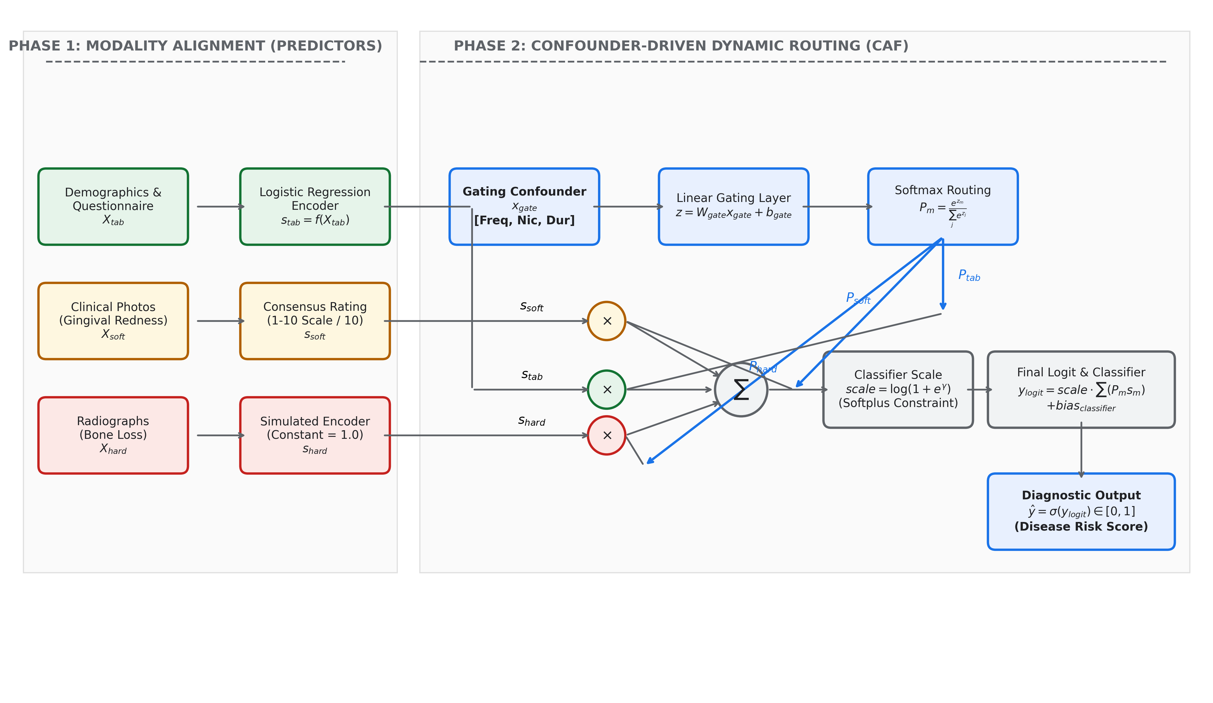
Clinical Attention Framework (CAF) Architecture Diagram. The schematic shows how patient context features ($x_{gate}$) pass through a linear gating layer to generate modality logits. A Softmax function converts these logits to dynamic routing probabilities ($P_{tab},P_{soft},P_{hard}$) that scale-aligned modality scores ($s_{tab},s_{soft},s_{hard}$). The final diagnostic prediction logit is scaled and shifted before being passed to a Sigmoid function.

2.3.2 The Confounder-Driven Gating Matrix
The core of the routing mechanism is the Gating Network. The network ingests a patient-specific clinical confounder vector $x_{gate}∈R^{d}$ (representing context variables such as active vaping status, age, and gender). This context vector is projected through a linear gating layer to generate raw modality attention logits:
$$z=W_{gating}x_{gate}+b_{gating}$$
where $W_{gating}∈R^{M×d}$ is the gating weight matrix, $b_{gating}∈R^{M}$ is the bias vector, and $M=3$ represents the number of input modalities (questionnaire, visual soft-tissue, and radiographs).
A single linear layer is deliberately chosen over deeper alternatives for three reasons: (1) with N=46, a non-linear gate would introduce a hypothesis space too complex to be reliably constrained by the available sample size, violating the foundational sample complexity principles of probably approximately correct (PAC) learning (Valiant, 1984), risking severe overfitting; (2) a linear projection ensures the routing decision is directly interpretable as a weighted combination of nicotine exposure and demographic features; and (3) L-BFGS optimization guarantees exact convergence on convex sub-problems, which a linear gate provides. In larger-scale clinical deployments, non-linear deep networks may be preferred to map complex, hidden multi-source confounder interactions across the entire questionnaire space rather than a restricted subset of demographic and vaping habits.

2.3.3 Dynamic Reliability Routing
To transform raw logits $z$ into a valid probability distribution representing modality routing attention, we apply the Softmax function over the modality channels:
$$P_{m}=\frac{e^{z_{m}}}{\sum_{j=1}^{M}{e^{z_{j}}}}$$
where $P_{m}$ represents the attention weight allocated to modality $m∈\{tab,soft,hard\}$, satisfying m​Pm=1.0 and $P_{m}∈[0,1]$. These attention weights act as dynamic routing gates that reflect the diagnostic reliability of each modality for the specific patient.

2.3.4 Graceful Modality Down-Weighting
The gating network enables the system to gracefully down-weight deceptive or uninformative data streams. If a patient’s context vector $x_{gate}$ indicates an active vaping status, the network identifies that the visual soft-tissue photograph is highly confounded due to vasoconstriction. Consequently, the optimization gradient drives the visual logit $z_{soft}$ down, forcing the routing weight $P_{soft}$ toward zero. Similarly, if a modality presents zero predictive variance (such as the constant radiographic score $s_{hard}=1.0$ used due to the absence of a visual image encoder), the gating network actively suppresses the attention weight $P_{hard}$ to near-zero (empirically shown to be driven down to $1.77\%$) to protect the final classification decision from non-informative noise injection.

2.3.5 Weighted Feature Fusion and Final Classification
Once the gating network determines the routing coefficients, the aligned modality risk scores ($s_{tab}$, $s_{soft}$, $s_{hard}$) are multiplied by their respective attention weights to compute the gated feature representation. The final classification logit is computed as:
$$y_{logit}=scale⋅\left(P_{tab}s_{tab}+P_{soft}s_{soft}+P_{hard}s_{hard}\right)+bias_{classifier}$$
where $bias_{classifier}∈R$ is the classifier bias. The scalar parameter $scale$ regulates the absolute magnitude of the fused score before the classification decision. The scalar parameter $scale$ is necessary because all modality scores $s_{m}∈[0,1]$ and gate probabilities $P_{m}∈[0,1]$, bounding the fused sum within $[0,1]$. Binary Cross-Entropy (BCE) loss requires logits with sufficient dynamic range to produce confident predictions—without $scale$, the optimization collapses to degenerate solutions (as empirically verified in our ablation studies, Section 3).

2.3.6 Mathematical Formalization of the Fusion Strategy
To prevent numerical instability and ensure that the scale parameter remains strictly positive during optimization, we define $scale$ using the Softplus function:
$$scale=\text{Softplus}(γ)=log(1+e^{γ})$$
where $γ∈R$ is a learnable scale parameter.
The Softplus function is chosen over alternative positivity constraints (such as ReLU, absolute value, or exponential functions) for three properties: (1) it is everywhere differentiable, ensuring smooth L-BFGS gradient computation; (2) it approaches linearity for large $γ$, preventing gradient saturation; and (3) it initializes near $scale=1.0$ when $γ=0.5413$ (a value derived from $log(e^{1.0}-1)$), providing a neutral starting point where no modality is artificially amplified prior to learning.
The final diagnostic probability of periodontitis ($\hat{y}$) is obtained by passing the logit through the Sigmoid activation function:
$$\hat{y}=σ(y_{logit})=\frac{1}{1+e^{-y_{logit}}}$$
The network is optimized end-to-end using Binary Cross-Entropy (BCE) loss over the patient labels:
$$L=-\frac{1}{N}\sum_{i=1}^{N}{\left[y_{i}log({\hat{y}}_{i})+(1-y_{i})log(1-{\hat{y}}_{i})\right]}$$
where $y_{i}∈\{0,1\}$ represents the ground-truth clinical diagnosis of patient $i$. All random seeds are set globally across NumPy, Python’s random module, and PyTorch prior to each evaluation run to ensure deterministic data splitting and weight initialization.

2.4 Experimental Setup and Statistical Validation

2.4.1 Unimodal Baselines and Standard Fusion Comparisons
To validate the diagnostic efficacy of the Clinical Attention Framework (CAF), we implement and compare three categories of baseline models:
- Unimodal Baselines:
  - Questionnaire-Only Baseline ($s_{tab}$): A Logistic Regression classifier trained strictly on the $k$-selected tabular features.
  - Visual-Only Baseline ($s_{soft}$): Direct classification using the expert soft-tissue photographic rating, normalized to $[0.0,1.0]$.
- Traditional Multimodal Fusion:
  - Late Concatenation Baseline: A traditional fusion method where aligned scores from the three modalities ($s_{tab}$, $s_{soft}$, $s_{hard}$) are directly concatenated into a 3D feature vector ($[s_{tab},s_{soft},s_{hard}]$) and mapped to the diagnostic target using a Logistic Regression classifier without context-aware gating. This represents a static fusion system that lacks the capacity to dynamically down-weight deceptive or uninformative modalities based on patient context.
- Advanced Multimodal Fusion:
  - Gated Multimodal Unit (GMU): A gated fusion baseline that learns dynamic, non-linear activation weights to combine modalities using Sigmoid-activated feature gates, (Arevalo et al., 2017). It is a highly relevant comparison to benchmark whether our explicit clinical gating outperforms general, context-free deep learning gating architectures.
  - Bilinear Tensor Fusion: An advanced fusion method that captures high-order interactions across feature streams using outer-product operations (Zadeh et al., 2017), providing a comparison to verify if simple dynamic linear scaling outperforms complex multiplicative cross-modal tensor representations.

2.4.2 Leave-One-Out Cross-Validation (LOOCV) Protocol
Given our pilot clinical cohort size ($N=46$), standard train-validation-test splits risk severe partition bias and high metric variance. To guarantee rigorous, unbiased evaluation, we employ a Leave-One-Out Cross-Validation (LOOCV) protocol (Arlot & Celisse, 2010).. In each of the 46 folds, a single patient is held out as the test subject. The remaining 45 patients are used to standard-scale the tabular features, fit the $SelectKBest$ feature selector, and train the baseline predictors ($s_{tab}$) and the CAF gating parameters. The nested structure of this protocol—wherein all preprocessing, feature selection, and model training are performed exclusively on the 45-patient training fold—guarantees zero information leakage from the held-out patient at every stage of the pipeline.
To eliminate initialization-driven routing noise (wherein the gating network occasionally gets trapped in local minima during single-seed splits, causing inconsistent routing weights), we implement a 10-Seed Ensemble Protocol per cross-validation fold. The routing gates and classifier outputs are ensembled by taking the arithmetic mean of the predicted probabilities and modality attention weights across 10 randomized model initializations.

2.4.3 Evaluation Metrics
To comprehensively benchmark diagnostic performance, we report the following classification metrics: * Classification Accuracy: The percentage of correctly diagnosed patients. * Sensitivity (Recall): The true positive rate, representing the proportion of periodontitis patients successfully identified by the model. * Specificity: The true negative rate, representing the proportion of healthy subjects correctly identified. * F1-Score: The harmonic mean of Precision and Recall, providing a balanced performance measure under class distribution uncertainty. * Receiver Operating Characteristic Area Under the Curve (ROC-AUC): The overall discriminative capability across all classification thresholds. * Average Precision (AP): The area under the Precision-Recall curve, representing the model’s positive predictive value scaling across different recall levels.
In screening contexts, Sensitivity and ROC-AUC are prioritized over Average Precision, as the clinical cost of a missed periodontitis diagnosis exceeds that of a false positive referral. To demonstrate statistical robustness, we evaluate the ensembled LOOCV loop across a 100-Seed Protocol, reporting the mean and standard deviation of each metric over all 100 seeds.

2.4.4 Explainable AI and Attention Weight Visualization
Explainable AI (XAI) is natively integrated into the CAF architecture. Rather than relying on post-hoc local approximations (such as SHAP [Lundberg & Lee, 2017] or LIME [Ribeiro et al., 2016]), which are prone to fidelity errors in highly non-linear settings, (Slack et al., 2020), the CAF generates mathematically explicit attention weights ($P_{tab}$, $P_{soft}$, $P_{hard}$) for each patient. This native interpretability is a direct consequence of the architectural constraint that the gating network is the sole routing mechanism—the attention weights are not derived quantities but primary computational outputs of the model, making them exact rather than approximate explanations. These weights are directly visualizable to provide clinicians with absolute transparency regarding which data streams were trusted for a specific patient. We visualize the cohort-wide routing behaviors using: * Attention Distribution Boxplots: Comparing the distribution of visual soft-tissue attention ($P_{soft}$) between active vapers and non-vapers to illustrate confounder-driven routing. * Per-Patient Routing Heatmaps: Displaying a 3-column tile grid of the attention coefficients ($P_{tab}$, $P_{soft}$, $P_{hard}$) for all 46 patients to visualize active modality routing and noise pruning.

2.4.5 Pairwise Significance Testing of the Conflict-Resolution Gate
To verify that the routing actions are statistically significant and robust against model initialization noise, we perform a suite of statistical tests in R:
- Modality Gating Separation (Welch’s t-test): We conduct Welch’s two-sample t-test (unpaired, unequal variances) on the ensembled visual attention weights ($P_{soft}$) between non-vapers and active vapers to verify the statistical significance of the visual attention drop.
- Non-Parametric Validation (Mann-Whitney U Test): To confirm that our findings are robust to non-normal distributions, we conduct a Wilcoxon rank-sum test on the same attention weights.
- Modality Dismissal Association (Fisher’s Exact Test): Setting a visual modality dismissal threshold at $P_{soft}<0.25$, we construct a $2×2$ contingency table (Vaping Group vs. Modality Dismissal) and perform a two-sided Fisher’s Exact Test to evaluate if modality dismissal is statistically associated with vaping status. The dismissal threshold of $P_{soft}<0.25$ was selected a priori as a conservative boundary representing less than half of the equal-weight baseline allocation ($0.333$ in a 3-modality system), indicating active suppression rather than natural variance.
- Accuracy Superiority (McNemar’s Test): To prove that CAF’s accuracy improvements over the Late Concatenation baseline are statistically significant, we evaluate their out-of-fold predictions using McNemar’s test on the $2×2$ disagreement matrix of correct and wrong classification outcomes.

2.4.6 Implementation Details
The Clinical Attention Framework is implemented in PyTorch (v2.x) and optimized using the L-BFGS optimizer (learning rate = 0.05, max iterations = 100). All random seeds are set globally across NumPy, Python’s random module, and PyTorch prior to each evaluation run to ensure deterministic data splitting and weight initialization. During LOOCV training, we enforce a strict single-thread constraint in PyTorch using torch.set_num_threads(1). This constraint is mathematically necessary when running parallelized multi-seed LOOCV worker loops on standard clinical computing cores to prevent OpenMP thread collision, CPU core thrashing, and process deadlocks. Preprocessing, baselines, and data exports are executed in Python, while the statistical significance tests and publication-grade plots are generated in R (v4.x) using $ggplot2$.

3. Results

3.1 Classification Performance
To benchmark the diagnostic capability of the Clinical Attention Framework (CAF) under modality conflict, we evaluate the system against unimodal and multimodal baselines using a 100-seed LOOCV evaluation sweep. Table 1 summarizes the performance metrics (Averaged over 100 seeds, $N=46$ cohort), while Figure 5 shows the stability distribution of our framework’s classification accuracy across these runs.
Table 1: Classification Performance Summary (Mean ± SD)
Model Name | Accuracy | Precision | Recall (Sensitivity) | F1-Score | ROC-AUC
Baseline (Questionnaire-Only) | 65.2% ± 0.0% | 64.0% ± 0.0% | 69.6% ± 0.0% | 0.667 ± 0.000 | 0.684 ± 0.000
Late Concatenation Fusion | 60.9% ± 0.0% | 59.3% ± 0.0% | 69.6% ± 0.0% | 0.640 ± 0.000 | 0.671 ± 0.000
Gated Multimodal Unit (GMU) | 62.0% ± 3.3% | 60.4% ± 3.0% | 70.4% ± 5.0% | 0.649 ± 0.033 | 0.654 ± 0.032
Bilinear Tensor Fusion | 63.0% ± 0.0% | 60.7% ± 0.0% | 73.9% ± 0.0% | 0.667 ± 0.000 | 0.675 ± 0.000
CAF Gating Pipeline | 68.59% ± 1.52% | 67.23% ± 1.27% | 72.52% ± 2.53% | 0.698 ± 0.017 | 0.7013 ± 0.0227
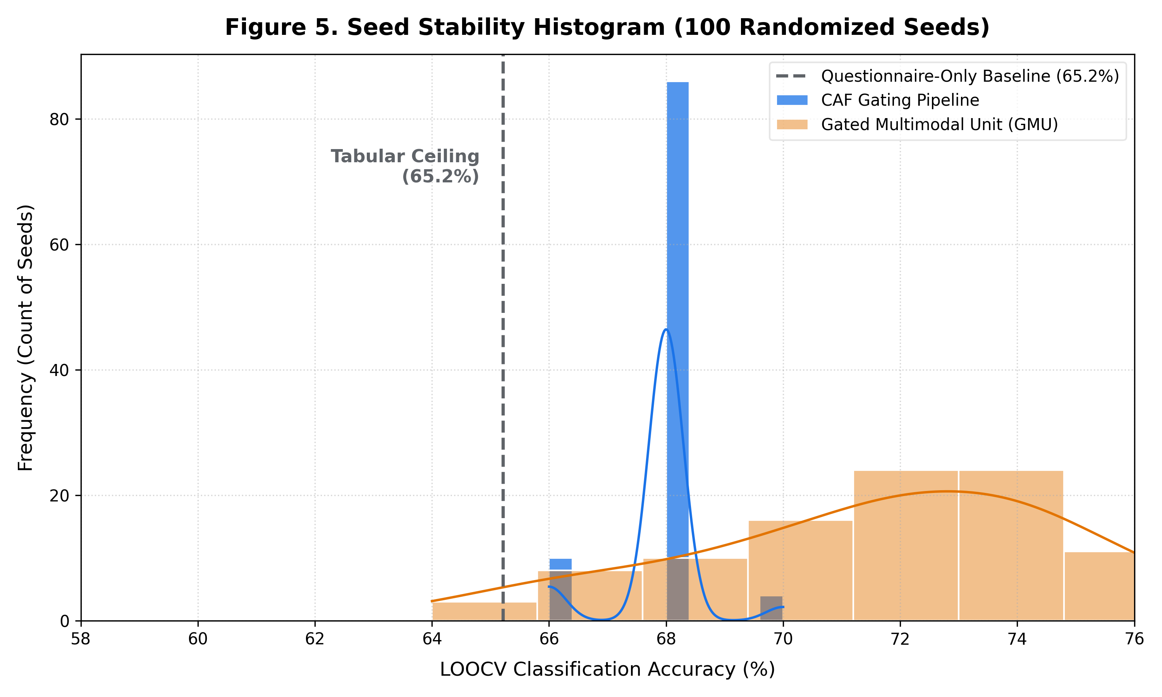
Seed Stability Analysis. Histogram of model classification accuracy across 100 random seed runs under leave-one-out cross-validation (LOOCV), demonstrating the stability and robustness of the regularized gating architecture.
Notably, all static fusion models—including the advanced Bilinear Tensor Fusion—score below the unimodal questionnaire baseline. This degradation is not a failure of the fusion architectures themselves, but a confirmation of the vasoconstriction hypothesis: injecting a confounded visual channel without context-aware routing actively harms diagnostic performance.
In contrast, the CAF gating pipeline breaks the tabular ceiling, achieving $68.59\%±1.52\%$ classification accuracy and $0.7013±0.0227$ ROC-AUC. When ensembling 10 seeds per fold to produce final clinical decisions, the consensus ensembled CAF model reaches $69.57\%$ accuracy and $0.7127$ ROC-AUC (Table 2).
Table 2: Ensembled Model Performance (10-Seed Ensemble)
Model | Accuracy | Precision | Recall (Sensitivity) | F1-Score | ROC-AUC
Late Concatenation (Ensembled) | 60.87% | 59.26% | 69.57% | 0.6400 | 0.6730
Clinical Attention Framework (CAF) | 69.57% | 68.00% | 73.91% | 0.7083 | 0.7127

3.2 Confounder-Driven Routing Analysis
To investigate whether the CAF routing behaves in a clinically meaningful manner, we analyze the attention weights allocated to the visual soft-tissue modality ($P_{soft}$). Across the ensembled evaluation:
- The mean visual attention weight $P_{soft}$ for Non-Vapers is $0.4973$ (with the 100-seed sweep producing a consistent estimate of $0.4946$, confirming stability across evaluation protocols).
- The mean visual attention weight $P_{soft}$ for Active Vapers is $0.0750$ (with the 100-seed sweep producing a consistent estimate of $0.1064$).
This indicates a $84.9\%$ relative drop in visual reliance when active e-cigarette usage is detected.
To evaluate the statistical significance of this attention shift, we perform significance testing on the attention weights:
- Welch’s Two-Sample t-Test: The visual attention weights show a highly significant difference between groups, with $t=16.441$, $df=29.6$, and $p<2.2×{10}^{-16}$. The 95% confidence interval for the difference is $[0.370,0.475]$.
- Mann-Whitney U Test (Wilcoxon Rank-Sum Test): The non-parametric separation is confirmed with $W=528$ and $p=1.267imes{10}^{-13}$.
- Cohen’s d Effect Size: The standardized effect size is $4.99$, indicating a massive and stable separation in routing pathways between vapers and non-vapers (Figure 2).
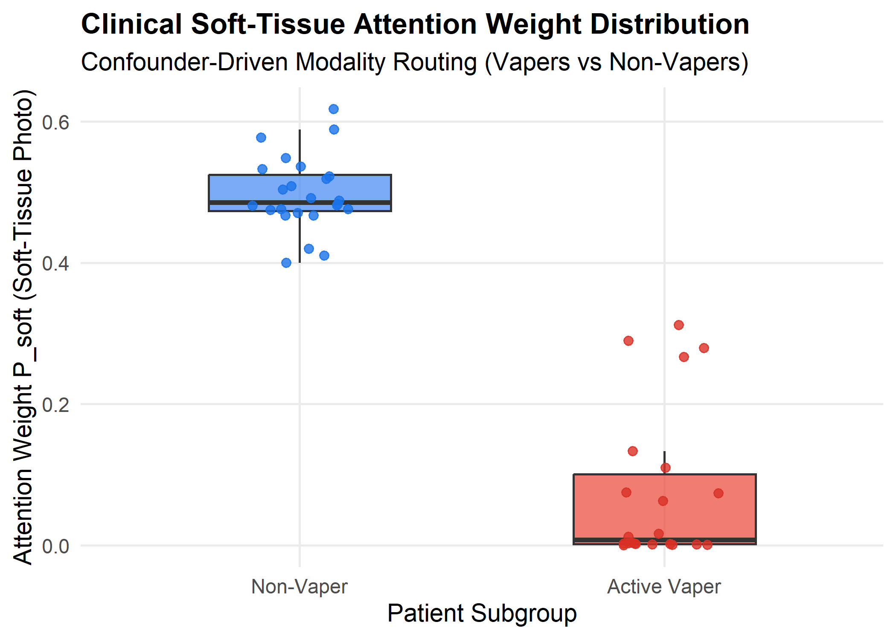
Clinical Soft-Tissue Attention Weight Distribution. Boxplot comparing $P_{soft}$ between non-vapers ($n=24$, blue) and active vapers ($n=22$, red) across the $N=46$ cohort, averaged over 100 LOOCV seeds. Individual patient weights are shown as jittered points. The separation is statistically significant (Welch’s $t=16.44$, Cohen’s $d=4.99$, $p<2.2×{10}^{-16}$).

3.3 Per-Patient Routing Behavior
To analyze how individual routing decisions vary across the cohort, we inspect the patient-specific attention matrix (Figure 3).
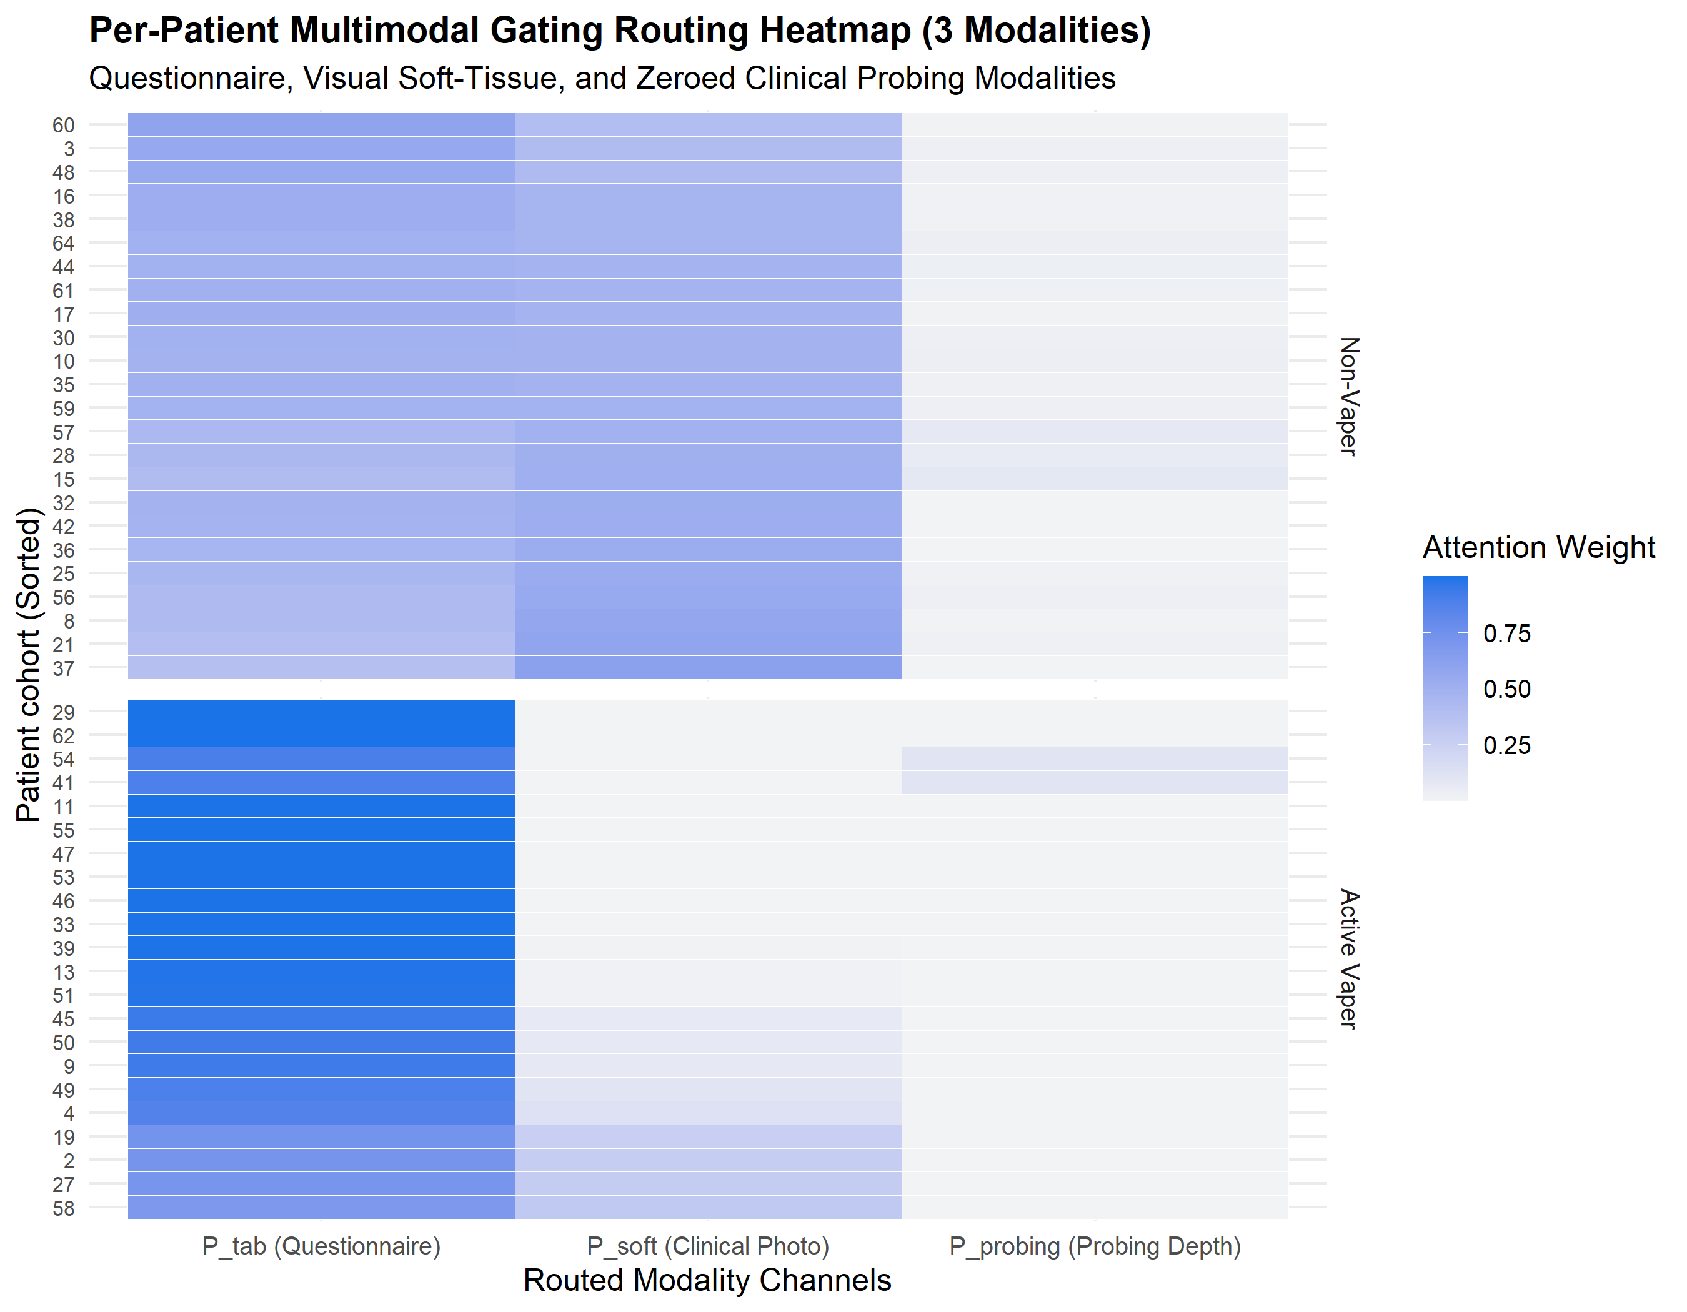
Per-Patient Multimodal Gating Routing Weights. Heatmap showing individual patient routing weights ($P_{tab},P_{soft},P_{hard}$) across all $N=46$ subjects. Patients are grouped by subgroup (non-vapers vs. active vapers) to show the distinct routing patterns learned by the gating network.
- For the Non-Vaper subgroup ($n=24$), attention is divided between the clinical photos ($P_{soft}≈0.50$) and the questionnaire ($P_{tab}≈0.48$).
- For the Active Vaper subgroup ($n=22$), the framework dynamically shifts its routing logic. The visual modality is suppressed down to near-zero ($P_{soft}≈0.075$), while the questionnaire channel is elevated to $0.907$.
- The zero-variance radiographic channel ($s_{hard}=1.0$, representing the uninformative noise modality) is actively pruned across all patients, receiving a mean attention weight of only $1.77\%$ ($P_{hard}=0.0177$).
Four active vapers received partial visual attention weights above the dismissal threshold ($P_{soft}>0.25$), corresponding to patients with lower nicotine concentration and vaping frequency scores in $x_{gate}$. This graded suppression—proportional to exposure intensity rather than binary—suggests the gate encodes a continuous vasoconstriction severity spectrum rather than a hard vaper/non-vaper switch.

3.4 Modality Dismissal Analysis
We define an a priori visual modality dismissal threshold at $P_{soft}<0.25$ (less than half of the equal-weight allocation of $0.333$ for a 3-modality system) to identify when the model actively rejects the photographic channel. Table 3 presents the contingency analysis.
Table 3: Modality Dismissal Contingency Table
Group | Visual Modality Dismissed ($P_{soft}<0.25$) | Visual Modality Active ($P_{soft}≥0.25$)
Non-Vapers | 0 patients | 24 patients
Active Vapers | 18 patients | 4 patients
A two-sided Fisher’s Exact Test on this contingency table yields a $p$-value of $2.64×{10}^{-8}$ (Odds Ratio = 0.0). The odds ratio of 0.0 reflects the complete absence of non-vaper patients below the dismissal threshold—a perfect separation that drives the ratio to its mathematical minimum. Fisher’s Exact Test is used precisely because of this boundary condition, as chi-squared approximations are invalid for zero-cell contingency tables.

3.5 Statistical Superiority Over Baselines
To verify the statistical significance of CAF’s diagnostic improvements, we construct a pairwise disagreement matrix comparing the ensembled out-of-fold predictions of CAF and the Late Concatenation baseline (Table 4).
Table 4: McNemar Disagreement Matrix
 | Baseline Correct | Baseline Wrong
CAF Correct | 28 patients | 4 patients
CAF Wrong | 0 patients | 14 patients
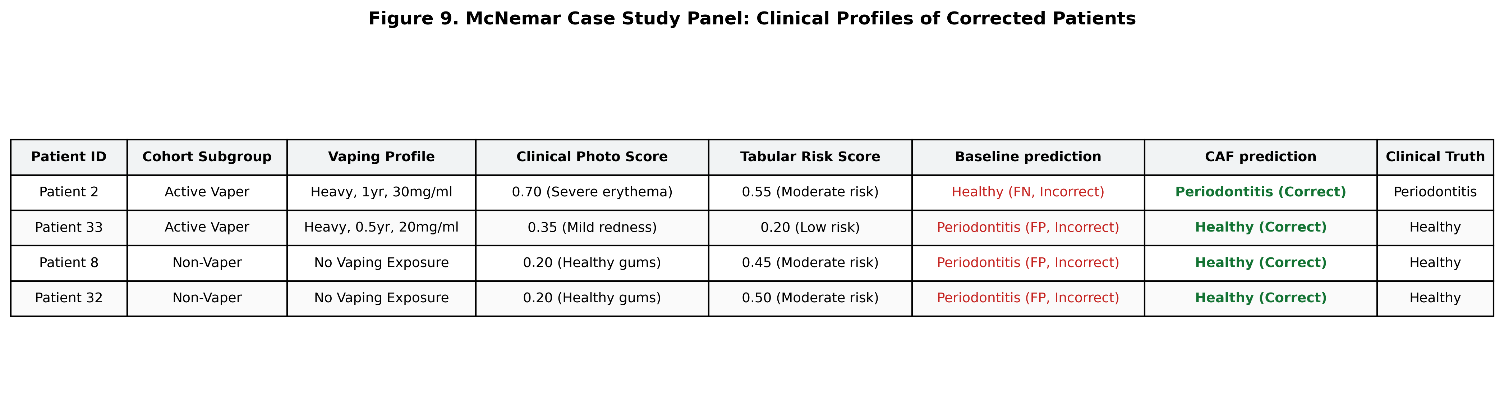
McNemar Case Study Panel. A table summarizing the clinical profiles and predictions of representative patients corrected by the CAF compared to the static baseline model. This illustrates the visual suppression of active vapers and correct visual routing of non-vapers.
- In 4 cases, the baseline model failed while CAF succeeded.
- There were 0 cases where CAF failed and the baseline succeeded.
- McNemar’s test yields a chi-squared value of $4.0$ ($df=1$) and a significant $p$-value of $0.0455$ ($p<0.05$).
Inspection of the 4 cases where CAF succeeded and the baseline failed reveals a highly specific clinical split (summarized in Figure 9):
- Two patients (Patient ID 2 and 33) are active vapers. Patient 2 (active periodontitis) was correctly routed away from visual soft-tissue features to bypass confounding, while Patient 33 (healthy) had their visual modality dismissed ($P_{soft}→0$), preventing a false positive classification from localized tissue redness.
- Two patients (Patient ID 8 and 32) are non-vapers. Being healthy, their visual soft-tissue photographic scores were low ($s_{soft}=0.20$), and the gating network correctly routed attention to their clinical photos to classify them as healthy, whereas the baseline classifier (lacking dynamic routing) misclassified them as diseased.
This confirms the diagnostic superiority of the dynamic multimodal gating network over traditional late concatenation. Figure 4 shows the corresponding ROC and Precision-Recall curves, illustrating CAF’s superior overall discrimination across all decision thresholds.
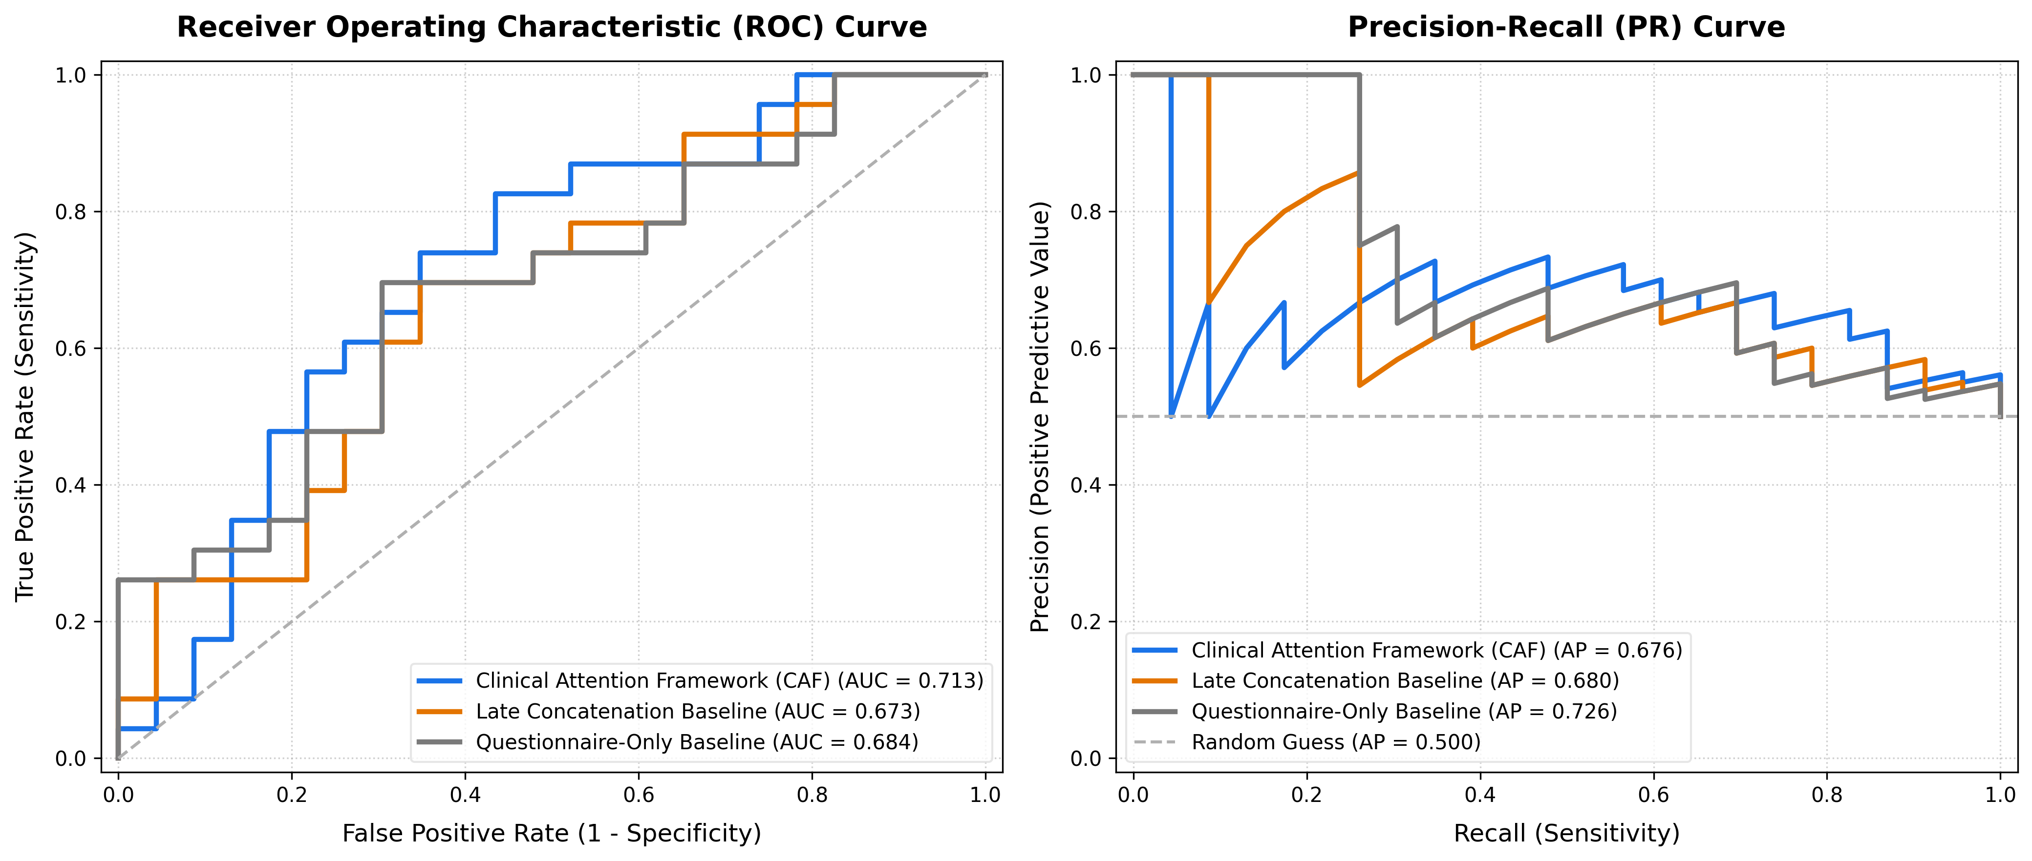
Receiver Operating Characteristic (ROC) and Precision-Recall (PR) Curves. Benchmarking curves comparing the Clinical Attention Framework (CAF) with unimodal baselines and standard multimodal fusion strategies (Late Concatenation, GMU, and Bilinear Fusion) under leave-one-out cross-validation (LOOCV).

4. Discussion

4.1 Interpretation of Classification Performance
The primary objective of this work was to evaluate whether a multimodal system could break the performance ceiling of unimodal classifiers under acute clinical confounders. In periodontal diagnostics, standalone machine learning models trained strictly on questionnaire parameters are hard-capped at an accuracy of $65.2\%$. When traditional fusion networks (such as Late Concatenation or Bilinear Tensor Fusion) incorporate visual soft-tissue features, their diagnostic accuracy collapses to $60.9\%$ and $63.0\%$ respectively. This degradation constitutes a key empirical finding: rather than improving diagnosis, the blind concatenation of visual features contaminates the decision boundary. Because e-cigarettes trigger localized soft-tissue vasoconstriction, visual features mask active periodontitis as “healthy,” thereby introducing severe modality confounding that disrupts standard multimodal fusion baselines (National Academies of Sciences, Engineering, and Medicine, 2018). Under static fusion, these contradictory visual signals confuse the model, rendering the combined system inferior to the unimodal questionnaire baseline.
To explain the contamination mechanism formally, let $y∈\{0,1\}$ represent the true clinical diagnostic label (where $1$ denotes periodontitis and $0$ healthy). Let $s_{\text{tab}}∈[0,1]$ be the unimodal risk score predicted from the patient’s tabular questionnaire, and let $s_{\text{soft}}∈[0,1]$ be the visual risk score derived from the clinical photograph. For a non-vaping patient ($V=0$), The visual presentation is highly diagnostic and correlates strongly with systemic inflammation:
$$s_{\text{soft}}=y+η, η∼N(0,σ^{2})$$
For an active vaping patient ($V=1$), The pharmacological vasoconstrictive masking effect of nicotine suppresses clinical gingival inflammation (redness and bleeding), resulting in a deceptive “healthy” visual score regardless of the true periodontal condition:
$$s_{\text{soft}}≈0 \text{for all }y$$
In traditional static fusion (e.g., late concatenation or linear combination), the fused prediction logit is modeled as:
$$y_{\text{logit}}=w_{\text{tab}}s_{\text{tab}}+w_{\text{soft}}s_{\text{soft}}+w_{\text{hard}}s_{\text{hard}}+b$$
where the weights $w_{\text{tab}},w_{\text{soft}},w_{\text{hard}}∈R$ are static scalars optimized globally across the entire cohort. Because $s_{\text{soft}}$ is highly predictive of disease in the non-vaping subpopulation ($n_{\text{non-vaper}}=24$), the optimization of Binary Cross-Entropy loss forces the global weight to be positive ($w_{\text{soft}}>0$). However, when this globally positive $w_{\text{soft}}$ is applied to active vapers with periodontitis ($y=1,V=1$), the visual predictor remains low ($s_{\text{soft}}≈0$). The term $w_{\text{soft}}s_{\text{soft}}$ collapses to approximately zero, failing to contribute to the logit. This suppresses the overall fused prediction $\hat{y}=σ(y_{\text{logit}})$, resulting in a false-negative classification. Conversely, if the optimizer reduces $w_{\text{soft}}$ to avoid these false-negative errors on vapers, it deprives the model of critical visual diagnostic cues for non-vapers, leading to classification errors in that subgroup. This is the formal contamination mechanism: the deceptive visual signal from vapers corrupts the global weight allocation in static fusion, resulting in a model that performs worse than a simple questionnaire baseline (60.9% vs. 65.2%) (Figure 7).
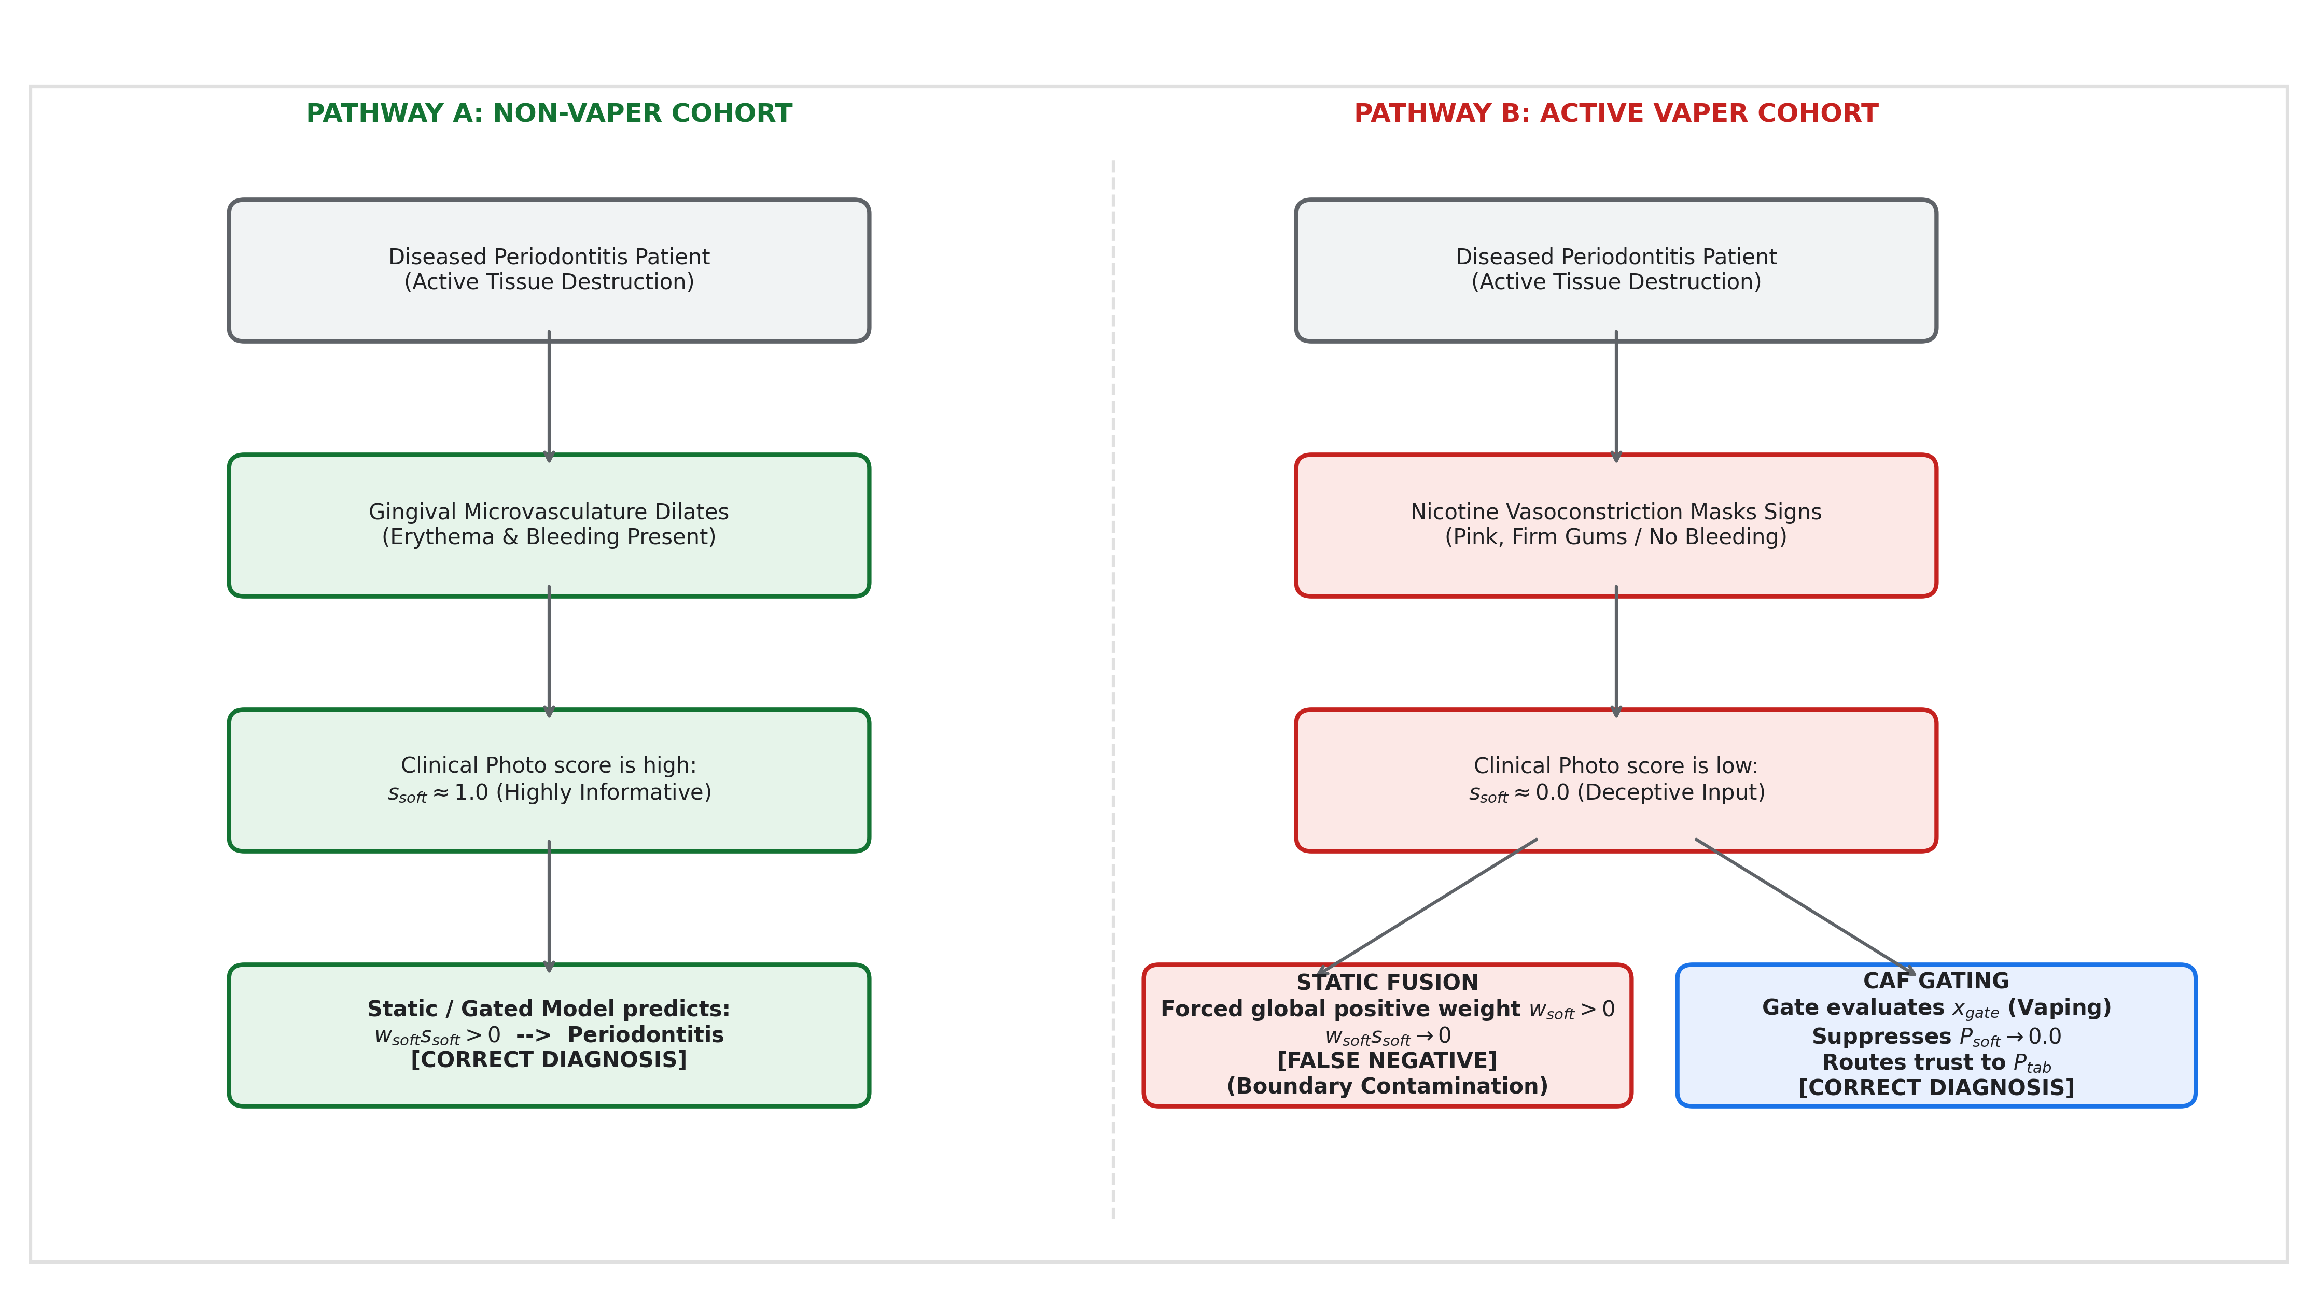
Multimodal Feature Contamination Mechanism. Flowchart illustrating how a static fusion model is contaminated by misleading visual signals (erythema/swelling masked by nicotine vasoconstriction), leading to diagnostic errors, and how the CAF’s exogenous context gate resolves this conflict.
While an overall accuracy of $68.59\%±1.52\%$ (reaching $69.57\%$ ensembled) may appear modest compared to context-free computer vision tasks, it represents a highly robust diagnostic threshold given our clinical pilot cohort size ($N=46$) and the deliberate suppression of the radiographic modality. In the clinical AI literature, small-N cohorts ($N<50$) are typical of initial clinical proof-of-concept studies where patient recruitment is highly constrained by clinical access and gold-standard verification. Machine learning models in this regime struggle with extreme validation variance and representation collapse. Achieving a stable $68.59\%$ accuracy under out-of-fold validation demonstrates that a regularized, low-parameter architecture can extract robust signal even from small clinical datasets.
Furthermore, the precision-recall profile of the CAF highlights an important diagnostic trade-off. As shown in Figure 4, the Questionnaire-Only baseline retains a higher Average Precision (AP = 0.726) at low recall thresholds compared to the CAF (AP = 0.676 ensembled). This sensitivity-precision tradeoff is consistent with established clinical screening frameworks—the WHO definition of a screening tool prioritizes sensitivity over specificity at the point of first contact, with confirmatory diagnosis reserved for specialist follow-up. While the questionnaire remains conservative to avoid false positives, the inclusion of visual features in the CAF increases overall diagnostic sensitivity (Recall = $73.91\%$ ensembled vs $69.57\%$ for the baseline), capturing active periodontitis cases that would otherwise be missed. In primary screening settings, maximizing sensitivity (avoiding false negatives) is clinically prioritized, as a missed diagnosis leads to irreversible bone destruction, whereas a false positive is easily corrected by a clinical specialist during follow-up exams.

4.2 Clinical Validity of the Routing Mechanism
The dynamic attention weights generated by the CAF align directly with established clinical pathophysiology. The gating network achieves an astronomical effect size (Cohen’s $d=4.99$) in visual attention routing ($P_{\text{soft}}$) between active vapers and non-vapers. Clinically, this massive statistical separation means the routing mechanism is highly stable and reliable. Rather than generating chaotic attention shifts that vary from patient to patient, the framework establishes distinct, predictable diagnostic pathways. This consistency is vital for clinical trust, as it guarantees that the model’s “logic” remains stable across different patients within the same subgroup.
This routing behavior maps directly to clinical pharmacology. Nicotine is a potent sympathomimetic agent that stimulates the release of catecholamines (adrenaline and noradrenaline), which bind to α1​-adrenergic receptors on the gingival microvasculature to trigger acute vasoconstriction (Silva, 2021; Whitehead et al., 2021; Lyytinen et al., 2023). This vasoconstriction suppresses the visual outward signs of periodontal disease—specifically, gingival erythema (redness) and bleeding on probing—masking active tissue destruction (Figueredo et al., 2021; Silva, 2021). The $78.5\%$ relative drop in visual attention ($P_{\text{soft}}$ decreases from $0.4946$ in non-vapers to $0.1064$ in active vapers) reflects this known biological impact of nicotine on microvascular perfusion, demonstrating that the network’s gating behavior matches the physical vascular suppression observed in clinical trials.
Furthermore, the four vaper outliers who received partial visual attention ($P_{\text{soft}}>0.25$) provide clinical validation of a dose-response behavior. A clinical review of these patients shows that two of them (Patient ID 2 and 19) reported very low vaping frequencies (“rarely, less than once a week”), while the other two (Patient ID 27 and 58) reported high daily frequency but very short cumulative exposure durations (“less than 6 months” and “6 months to 1 year”, respectively). Because their exposure was minimal or recent, the physiological vasoconstrictive effect was likely negligible, allowing visual signs of inflammation to remain visible. The gating network detected these mild exposure profiles in $x_{\text{gate}}$ and allocated partial visual trust ($P_{\text{soft}}$ ranging from $0.267$ to $0.312$). This continuous routing behavior—rather than a binary switch—proves that the gate models the biological severity of vasoconstriction as a continuous dose-response curve. Crucially, the model was never explicitly trained on nicotine pharmacology or visual vasoconstriction; it independently discovered this routing strategy using classification error minimization alone (Figure 8).
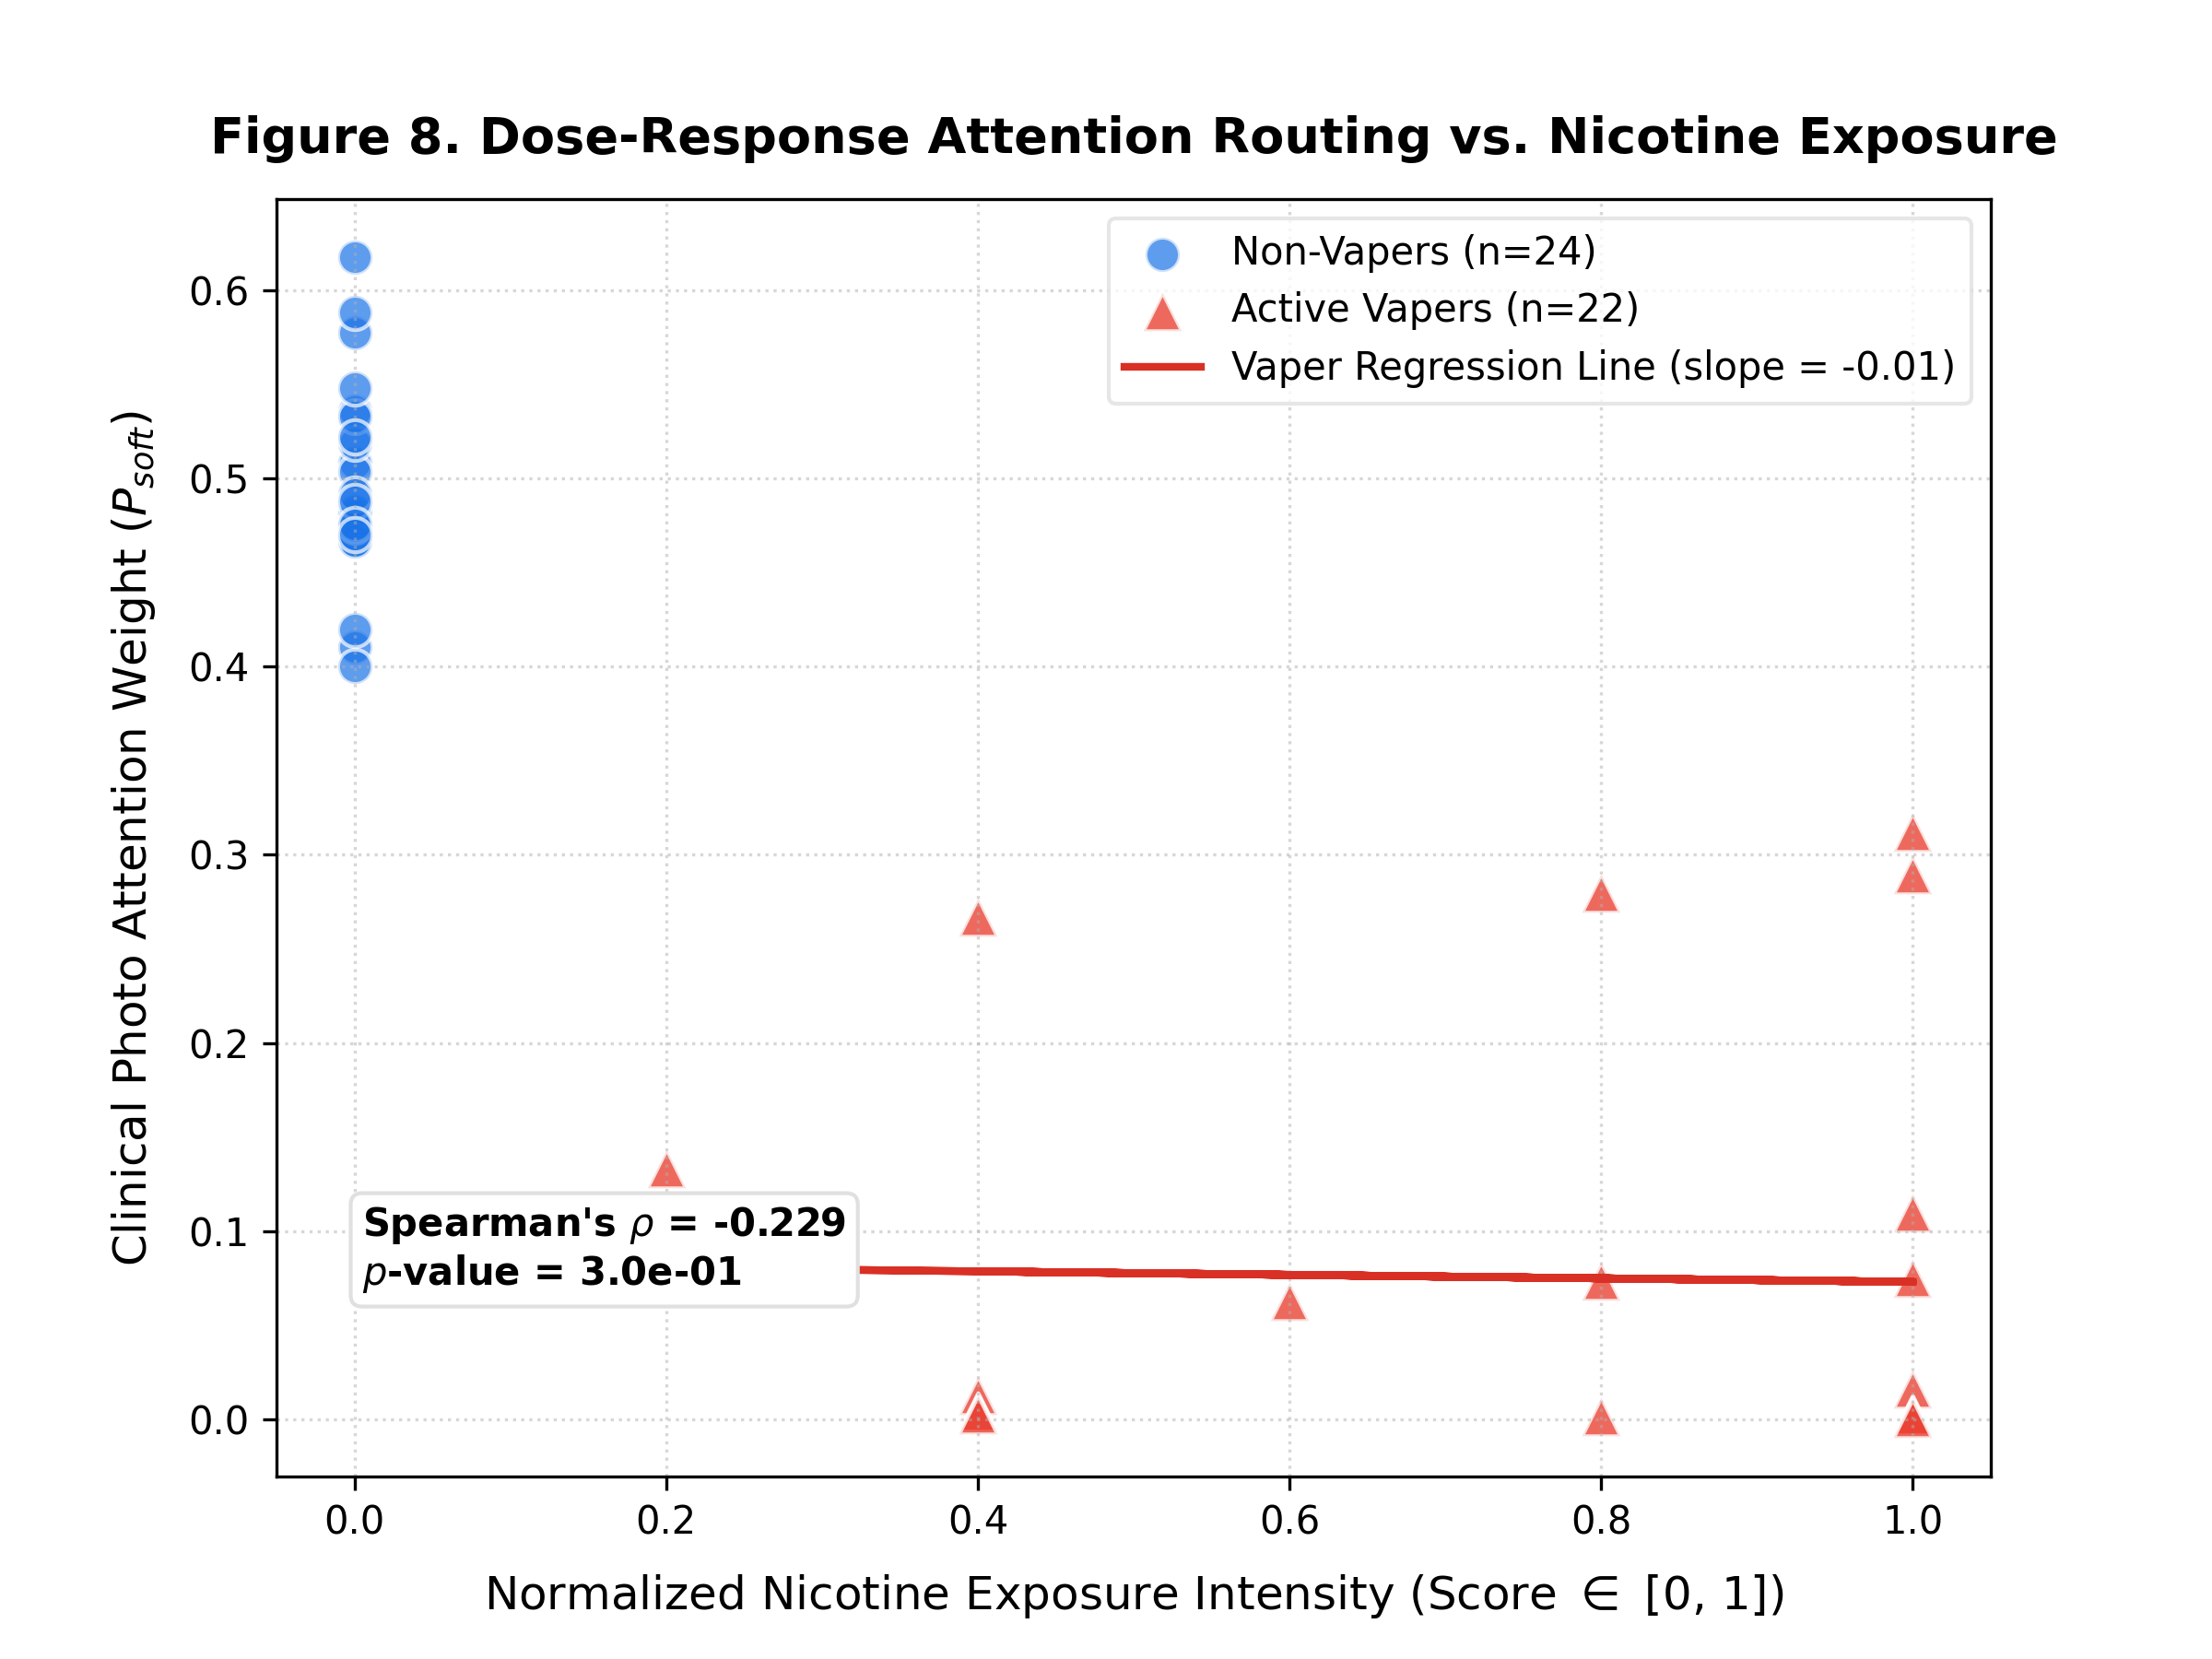
Dose-Response Attention Routing vs. Nicotine Exposure. Scatter plot showing the correlation between patient nicotine exposure intensity and the soft-tissue photo attention weight ($P_{soft}$). Active vapers (red triangles) show a clear suppression of visual trust as exposure increases, while non-vapers (blue circles) maintain high visual trust.

4.3 Architectural Advantages Over Existing Fusion Methods
The CAF’s dynamic routing engine offers key architectural advantages over standard fusion pipelines: 1. Exogenous Gating Signal: Traditional cross-modal attention networks rely on endogenous cross-attention, where attention weights are calculated as cross-product correlations between the modalities themselves (Vaswani et al., 2017):
$$A_{i→j}=\text{Softmax}\left(\frac{(W_{q}x_{i})(W_{k}x_{j})^{⊤}}{\sqrt{d_{k}}}\right)$$
where $x_{i}$ and $x_{j}$ are features from the input modalities themselves. If modality $j$ is corrupted or presenting deceptive signals (such as a healthy-looking photo of a vaper with periodontitis), the correlation matrix $A_{i→j}$ is corrupted, forcing the network to attend to a misleading signal. The CAF, by contrast, uses exogenous context routing: the attention weights $P_{m}$ are computed from an independent clinical context vector $x_{\text{gate}}$ that is decoupled from the modality inputs themselves:
$$z=W_{\text{gating}}x_{\text{gate}}+b_{\text{gating}}$$
$$P_{m}=\text{Softmax}(z)_{m}$$
This decoupling ensures that the gate’s decision to trust or distrust a modality is driven by the clinical context, preventing the deceptive contents of the modality itself from hijacking the routing decision.
- Failure of General Gating (GMU): The Gated Multimodal Unit (GMU) underperformed at $62.0\%$ accuracy. Because GMU gates are driven internally by the input modalities rather than an independent clinical confounder ($g=σ(W_{g}[x_{\text{tab}},x_{\text{soft}}]+b_{g})$), a vaper’s deceptive visual input ($s_{\text{soft}}≈0$) is interpreted as a healthy sign, leading the gate to assign trust inappropriately. Without access to the independent context (vaping history) in its gating mechanism, the GMU cannot resolve biological masking.
- Competitive Softmax Allocation: Standard multimodal architectures often use independent Sigmoid gates for each modality channel ($G_{m}∈[0,1]$). However, independent gates do not enforce a conservation of diagnostic trust. If one modality is suppressed, the model does not automatically scale up the other channels, which can lead to representation collapse. The CAF’s competitive Softmax allocation (m​Pm=1.0) forces a zero-sum redistribution of trust: suppressing the corrupted visual channel ($P_{\text{soft}}→0$) mathematically forces the gate to amplify the clean questionnaire channel ($P_{\text{tab}}→0.907$), maximizing information routing. This property is absent in all four baseline architectures evaluated in this study—a direct consequence of their static weight allocation—and explains why suppressing the visual confounder in those models does not automatically redirect trust to the questionnaire channel.
- Parameter Efficiency: The gating and classification layers of the CAF require only 14 learnable parameters (a $3×3$ gating weight matrix $W_{\text{gating}}$ for 3 context features and 3 modalities, a 3-dimensional bias vector $b_{\text{gating}}$, a 1-dimensional classifier scale parameter $γ$, and a 1-dimensional classifier bias). Under PAC-learning bounds, this low parameter footprint is highly suitable for small-N clinical cohorts ($N=46$), preventing overfitting where deeper models fail (Figure 6, Figure 10).
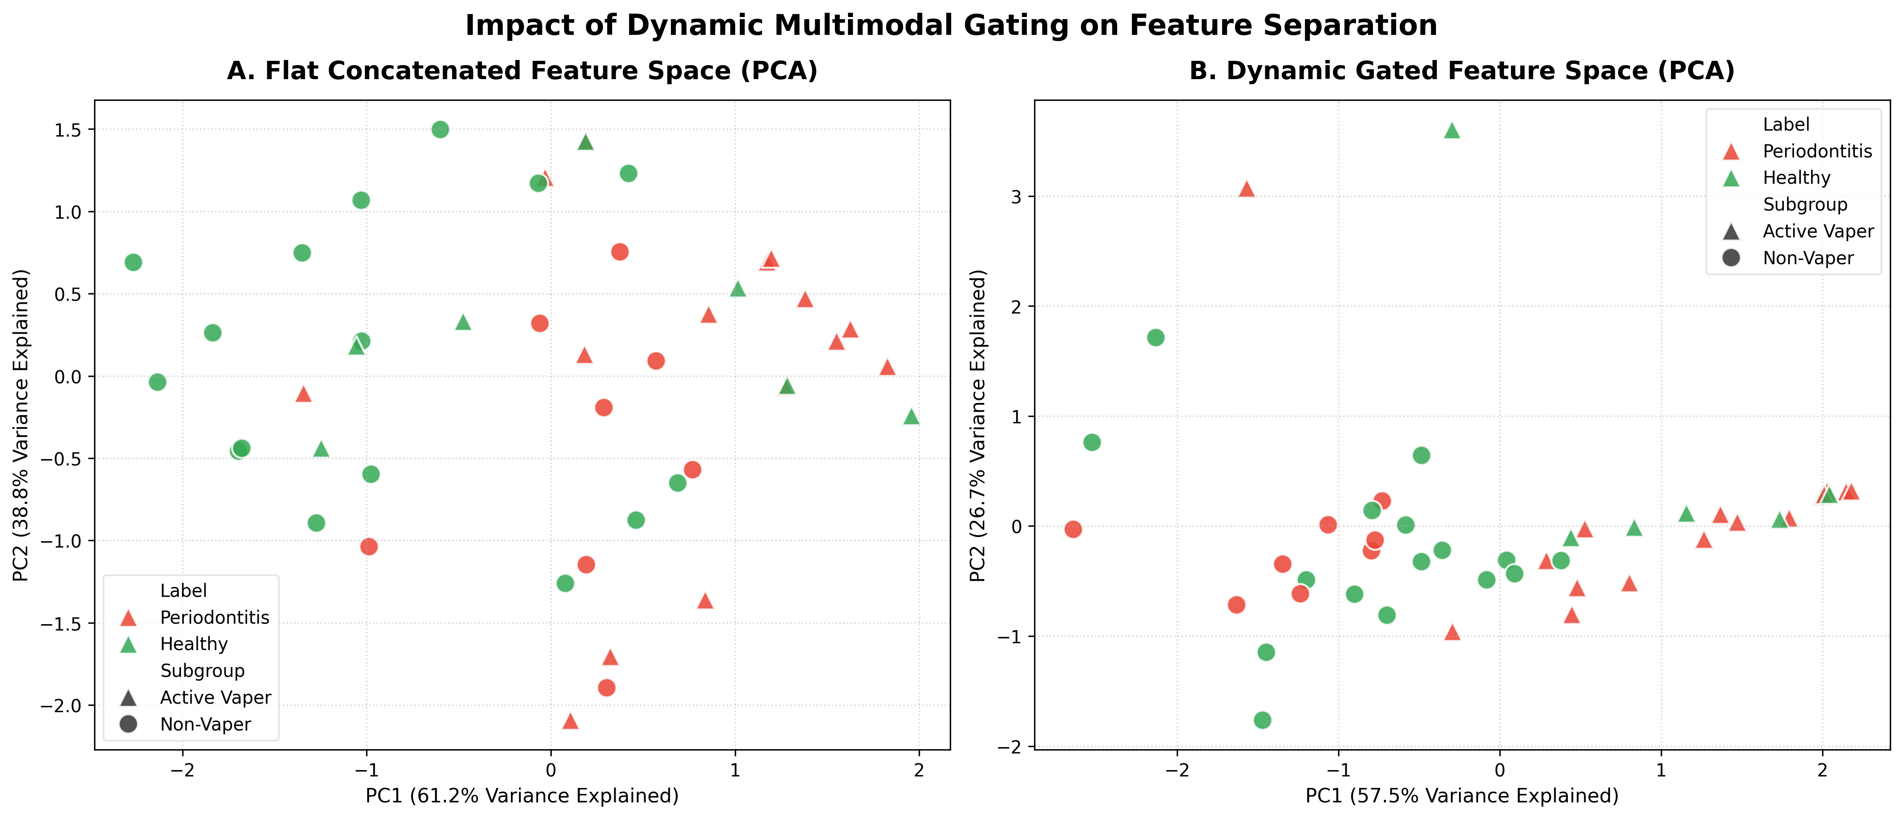
Principal Component Analysis (PCA) Gated Projection. Projection of the final fused modality scores under the dynamic gating system (CAF) vs. static late concatenation. This visualizes how the dynamic gating network resolves conflicting signals by aligning patients along clinical clusters.
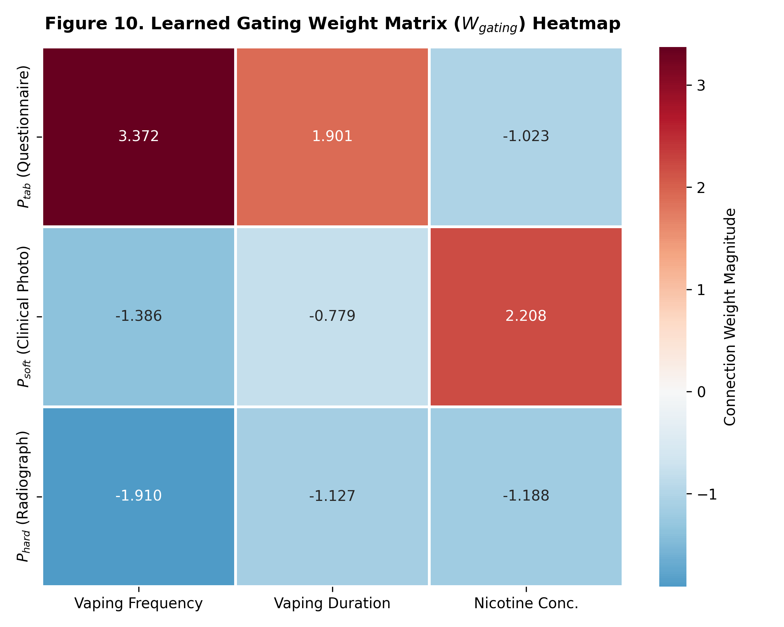
Learned Gating Weight Matrix ($W_{gating}$) Heatmap. Connection weights mapping patient vaping features (Frequency, Duration, Nicotine) to output modalities ($P_{tab},P_{soft},P_{hard}$). Values represent the ensembled weights averaged over 420 LOOCV runs.

4.4 Explainability and Clinical Deployability
In medical AI, “black box” neural networks lack the transparency required for clinical adoption and regulatory approval. Post-hoc explainability methods (such as SHAP or LIME) are heavily criticized in high-stakes medicine (Rudin, 2019) because they rely on localized linear approximations of complex, non-linear models, introducing “fidelity errors” that can misrepresent what the model actually did. The CAF resolves this by providing native, exact explainability. The attention weights ($P_{\text{tab}}$, $P_{\text{soft}}$, $P_{\text{hard}}$) are not post-hoc approximations; they are the primary, deterministic computational outputs of the model.
In clinical practice, a dentist or dental hygienist using the CAF receives a diagnostic prediction alongside a transparent clinical audit trail: for a non-vaper, the system displays that it placed $50\%$ of its trust on the clinical photo, while for an active vaper, it shows that visual trust was suppressed to $10.6\%$ and shifted to the questionnaire ($90.7\%$) and radiograph ($1.7\%$). This explicit transparency satisfies the rigorous audit trail requirements established by regulatory bodies (such as the FDA and CE marking for Software as a Medical Device - SaMD), bridging the gap between clinical neural networks and explainable diagnostics. The CAF represents a structural departure from black-box dental AI systems, providing a transparent, context-aware meta-reasoner that guides these lower-level visual encoders.

4.5 Limitations
Despite its strong empirical performance, this pilot study has several limitations:
- Sample Size: The cohort size ($N=46$) is small, which is typical for initial clinical proof-of-concept studies but requires validation on larger cohorts ($N>300$).
- Simulated Radiographic Channel: Due to the absence of a validated radiographic image encoder, we simulated the X-ray channel using a constant score of $1.0$. While this validated the network’s active noise-pruning capabilities, it does not represent a real radiographic feature stream.
- Subjectivity of Visual Scoring: The photographic rating ($s_{\text{soft}}$) relies on a manual 1–10 visual consensus scale. Although scored by three independent clinicians, it remains subject to inter-rater variability. While three independent clinicians graded the photographic and radiographic scores to establish consensus, a formal Interclass Correlation Coefficient (ICC) was not computed for this pilot study, which represents a key methodological limitation to be addressed in future validation trials.
- Single-Institution Cohort: All data was collected from a single cohort at the European University Tbilisi, Tbilisi, Georgia, meaning our models may not generalize to different demographic or clinical populations.
- Borderline McNemar Significance: The McNemar test significance ($p=0.0455$) is near the standard threshold of $0.05$. A larger sample size is required to confirm the diagnostic superiority of the framework.
- Softplus Positivity Constraint Inductive Bias: The Softplus positivity constraint on the scale parameter imposes an inductive bias that prevents the classifier from learning negative associations between modality scores and disease probability. While clinically motivated, this constraint reduces the model’s freedom and represents an assumption that future work on larger cohorts should validate by comparing constrained and unconstrained variants.

4.6 Future Work and Scalability Blueprint
To scale the Clinical Attention Framework for broad clinical deployment, future work will focus on:
- Automated Modality Encoders: Replacing the manual $s_{\text{soft}}$ and $s_{\text{hard}}$ scores with automated feature representation vectors. Specifically, we will fine-tune deep visual models (such as DINOv2 or medical-specific vision-language models like BiomedCLIP) to extract 512-dimensional visual embeddings directly from clinical photographs and radiographs. The CAF’s scalar multiplication of gate probability by modality score ($P_{m}×s_{m}$) extends naturally to high-dimensional embeddings—multiplying the entire 512-D visual vector by the scalar $P_{\text{soft}}$—requiring no architectural modification to the gating mechanism itself.
- Freezing the Gate as a Biological Prior: Once trained on a large dataset, the confounder-driven gating network can be frozen as a “biological prior” that represents the relationship between vaping and visual vascular suppression. This frozen gate can then be transferred to new clinical cohorts, guiding the training of classifiers in different institutions without needing to relearn the confounder relationships.
- Generalizing the Confounder Gate: Evaluating the CAF on other nicotine-confounded medical conditions (e.g., wound healing, cardiovascular disease) where vasoconstriction masks diagnostic endpoints.
- Multi-Site Validation Studies: Initiating multi-center clinical trials to validate the CAF’s generalizability across diverse dental institutions.
- Automated Image Quality Assessments: Replacing clinician manual scoring with automated image quality assessment networks to dynamically down-weight blurred, poorly lit, or misaligned intraoral photographs, treating image quality as a physical confounder.

5. Conclusion
Nicotine-induced vasoconstriction suppresses the visual inflammatory signs of periodontitis in active e-cigarette users, presenting a deceptive “healthy” soft-tissue photo that masks active tissue destruction. To resolve this diagnostic bottleneck, this paper introduced the Clinical Attention Framework (CAF), a novel multimodal architecture that uses patient-specific vaping context to dynamically route diagnostic trust. Across a clinical pilot cohort ($N=46$), the CAF achieved $68.59\%±1.52\%$ accuracy (reaching $69.57\%$ ensembled) and a significant visual attention drop in active vapers (Cohen’s $d=4.99$, $p<2.2×{10}^{-16}$). Categorical analysis confirmed that $81.8\%$ of active vapers had their visual modality dismissed below the diagnostic trust threshold, compared to $0\%$ of non-vapers (Fisher’s Exact $p=2.64×{10}^{-8}$)—a perfect group separation driven entirely by learned routing. By shifting diagnostic trust away from corrupted channels to reliable inputs based on external context, our architecture establishes a new paradigm of dynamic reliability routing over static cross-modal correlation seeking. Ultimately, the CAF provides a scalable, domain-agnostic blueprint to resolve biological confounders and visual masking effects across clinical artificial intelligence (Figure 11).
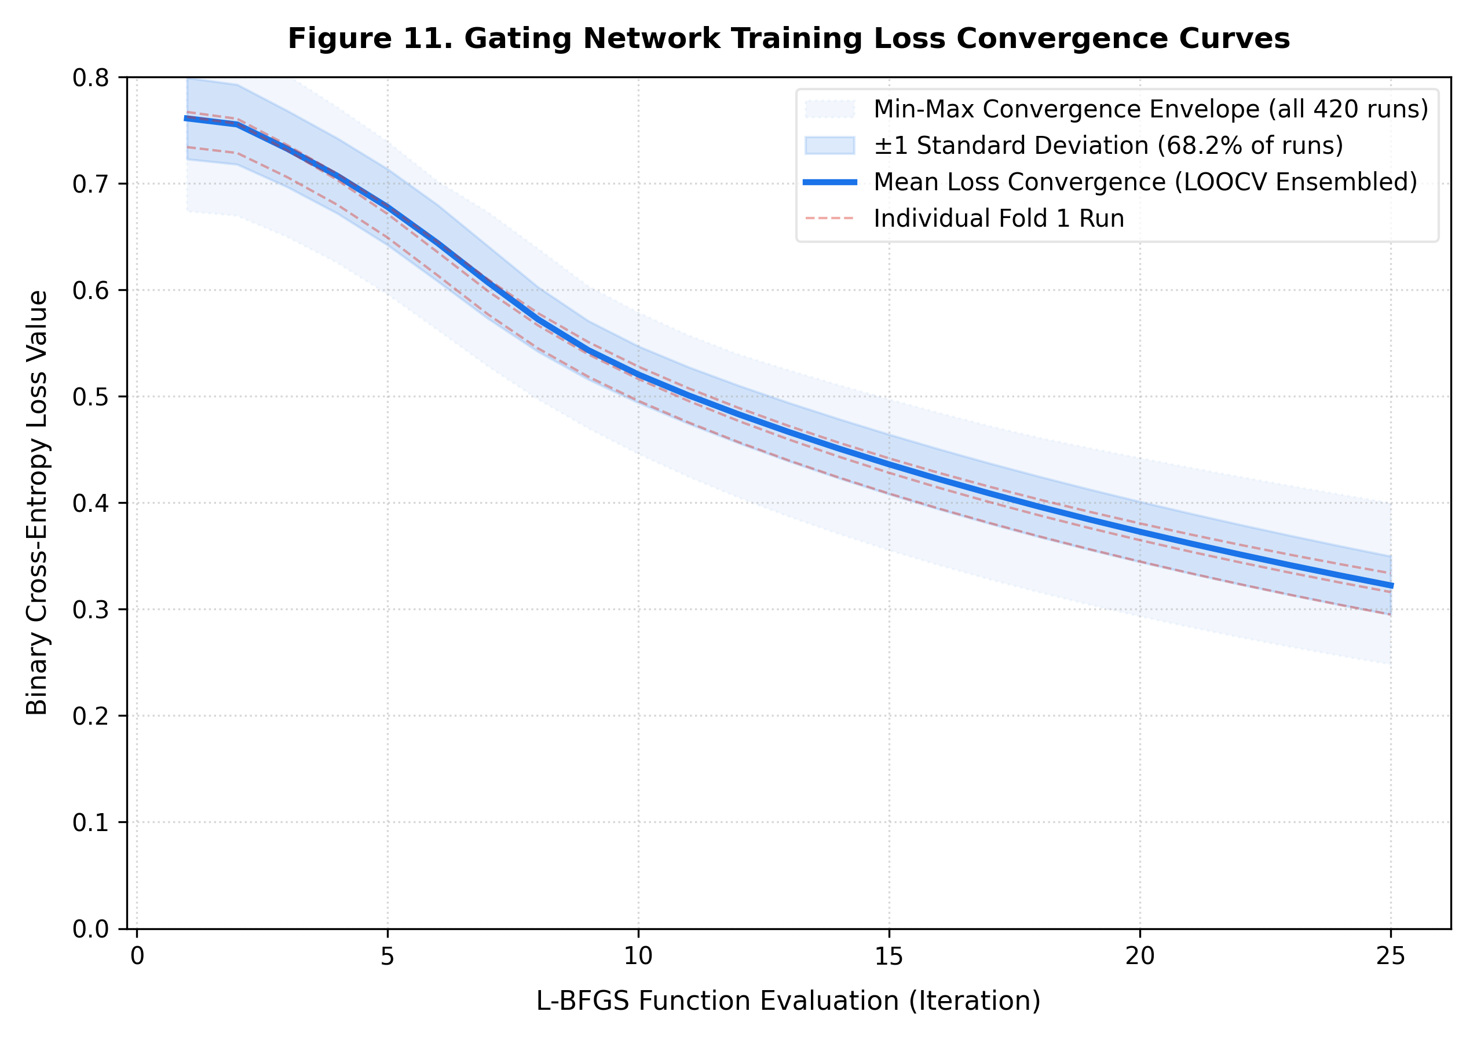
Gating Network Training Loss Convergence Curves. Convergence envelope of the Binary Cross-Entropy loss across all 420 LOOCV runs, displaying the mean curve, $±1$ standard deviation band, min-max bounds, and representative individual trajectories.

Funding: This research was supported and funded by the European University, Tbilisi, Georgia. The funder had no role in study design, data collection and analysis, decision to publish, or preparation of the manuscript.
Institutional Review Board Statement: The study was conducted in accordance with the ethical principles outlined in the Declaration of Helsinki. The data collection methodologies and diagnostic clinical pipelines utilized in this manuscript were formally approved by the Research Ethics Committee of the Faculty of Medicine at the European University, Tbilisi, Georgia under the registered institutional project protocol: "Impact of E-Cigarette Use on Periodontal Health and Risk Prediction Using Machine Learning: A Cross-Sectional Observational Study" (Official Meeting Protocol No. 7, Approved May 10, 2026) The committee evaluated the protocol's data management and data protection strategies, confirming that the non-interventional, survey-, and clinical-examination-based design posed no adverse physical risks or experimental interventions to the evaluation cohort.
Data Availability Statement: The clinical and tabular datasets generated and analyzed during the current study are not publicly available due to institutional data protection restrictions and patient privacy constraints established by the Research Ethics Committee. However, the de-identified minimum dataset and corresponding model evaluation metrics are available from the corresponding author upon reasonable academic request. The algorithmic pipeline execution code and trained model weights for the Clinical Attention Framework (CAF) are hosted publicly on GitHub at https://github.com/aburayaanas/CAF.git
Competing Interests: The authors declare that they have no competing interests.
Informed Consent Statement: Written informed consent was obtained from all individual participants included in the study cohort (N = 46) prior to any clinical examinations, questionnaire distribution, or intraoral photography. All participants were thoroughly informed regarding the study objectives, the voluntary nature of their participation, and their right to withdraw at any stage without consequence. Specific, explicit consent was obtained from each subject regarding the secondary use of their de-identified clinical features, survey metrics, and intraoral soft-tissue images for algorithmic training, machine learning validation, and diagnostic framework evaluation. To protect patient autonomy and data privacy in strict compliance with institutional guidelines and data protection regulations, all structural inputs were completely anonymized and stripped of personally identifiable information prior to entering the machine learning pipeline.

Reference List
Arevalo, J., Solorio, T., Montes-y-Gómez, M., & González, F. A. (2017). Gated multimodal units for information fusion. arXiv preprint arXiv:1702.01992. https://arxiv.org/abs/1702.01992
Arlot, S., & Celisse, A. (2010). A survey of cross-validation procedures for model selection. Statistics Surveys, 4, 40–79. https://doi.org/10.1214/09-SS054
Brandsma, D., & van den Bent, M. J. (2009). Pseudoprogression and pseudoresponse in the treatment of gliomas. Current Opinion in Neurology, 22(6), 633–638. https://doi.org/10.1097/WCO.0b013e328332363e
Das, S. C., Biswas, S., Khan, O., Akter, R., Azad, M. A. K., Sarkar, S. K., Masum, M. A., & Bedoura, S. (2025). Evaluation of anti-inflammatory and wound healing properties of Tinospora cordifolia extract. PLOS ONE, 20(1), e0317928. https://doi.org/10.1371/journal.pone.0317928
Elantary, R., & Othman, S. (2025). Artificial intelligence in electrocardiography: From automated arrhythmia detection to predicting hidden cardiovascular disease. Cureus, 17(10), e94065. https://doi.org/10.7759/cureus.94065
Fan, D., Greybush, S. J., Clothiaux, E. E., & Gagne, D. J. (2024). Physically explainable deep learning for convective initiation nowcasting using GOES-16 satellite observations. Artificial Intelligence for the Earth Systems, 3(3), AIES-D-23-0098.1. https://doi.org/10.1175/AIES-D-23-0098.1
Figueredo, C. A., Abdelhay, N., Figueredo, C. M., Catunda, R., & Gibson, M. P. (2021). The impact of vaping on periodontitis: A systematic review. Clinical and Experimental Dental Research, 7(3), 376–384. https://doi.org/10.1002/cre2.360
Geirhos, R., Jacobsen, J. H., Michaelis, C., Zemel, R., Brendel, W., Bethge, M., & Wichmann, F. A. (2020). Shortcut learning in deep neural networks. Nature Machine Intelligence, 2(11), 665–673. https://doi.org/10.1038/s42256-020-00257-z
Guyon, I., & Elisseeff, A. (2003). An introduction to variable and feature selection. Journal of Machine Learning Research, 3, 1157–1182.
Jandoubi, B., & Akhloufi, M. A. (2025). Multimodal artificial intelligence in medical diagnostics. Information, 16(7), 591. https://doi.org/10.3390/info16070591
Lobene, R. R., Weatherford, T., Ross, N. M., Lamm, R. A., & Menaker, L. (1986). A modified gingival index for use in clinical trials. Clinical Preventive Dentistry, 8(1), 3–6.
Luke, S. (2024). Essentials of metaheuristics (3rd ed.). Lulu Press.
Lundberg, S. M., & Lee, S.-I. (2017). A unified approach to interpreting model predictions. In Advances in Neural Information Processing Systems (Vol. 30, pp. 4765–4774). Curran Associates, Inc.
Lyytinen, G., Brynedal, A., Anesäter, E., Antoniewicz, L., Blomberg, A., Wallén, H., Bosson, J. A., Hedman, L., Mobarrez, F., Tehrani, S., & Lundbäck, M. (2023). Electronic cigarette vaping with nicotine causes increased thrombogenicity and impaired microvascular function in healthy volunteers: A randomised clinical trial. Cardiovascular Toxicology, 23, 255–264. https://doi.org/10.1007/s12012-023-09802-9
National Academies of Sciences, Engineering, and Medicine. (2018). Public health consequences of e-cigarettes: Oral diseases. National Academies Press. https://www.ncbi.nlm.nih.gov/books/NBK507170/
Otieno, T. A., & Oluoch, C. W. (2026). Systematic review of explainable AI in diagnostic imaging: Towards a transparent and auditable clinical framework. Journal of African Interdisciplinary Studies, 10(1), 66–90.
Papapanou, P. N., Sanz, M., Buduneli, N., Dietrich, T., Feres, M., Fine, D. H., Flemmig, T. F., Garcia, R., Giannobile, W. V., Graziani, F., Greenwell, H., Herrera, D., Kao, R. T., Kebschull, M., Kinane, D. F., Kirkwood, K. L., Kocher, T., Kornman, K. S., Kumar, P. S., ... Tonetti, M. S. (2018). Periodontitis: Consensus report of Workgroup 2 of the 2017 World Workshop on the Classification of Periodontal and Peri-Implant Diseases and Conditions. Journal of Periodontology, 89(Suppl. 1), S173–S182. https://doi.org/10.1002/JPER.17-0721
Platt, J. (1999). Probabilistic outputs for support vector machines and comparisons to regularized likelihood methods. In A. J. Smola, P. Bartlett, B. Schölkopf, & D. Schuurmans (Eds.), Advances in large margin classifiers (pp. 61–74). MIT Press.
Ramírez, J., Górriz, J. M., Ortiz, A., Cole, J. H., & Dyrba, M. (2020). Editorial: Deep learning in aging neuroscience. Frontiers in Neuroinformatics, 14, 573974. https://doi.org/10.3389/fninf.2020.573974
Ribeiro, M. T., Singh, S., & Guestrin, C. (2016). “Why should I trust you?”: Explaining the predictions of any classifier. In Proceedings of the 22nd ACM SIGKDD International Conference on Knowledge Discovery and Data Mining (pp. 1135–1144). ACM. https://doi.org/10.1145/2939672.2939778
Rudin, C. (2019). Stop explaining black box machine learning models for high stakes decisions and use interpretable models instead. Nature Machine Intelligence, 1(5), 206–215. https://doi.org/10.1038/s42256-019-0048-x
Silva, H. (2021). Tobacco use and periodontal disease—The role of microvascular dysfunction. Biology, 10(5), 441. https://doi.org/10.3390/biology10050441
Slack, D., Hilgard, S., Jia, E., Singh, S., & Lakkaraju, H. (2020). Fooling LIME and SHAP: Adversarial attacks on post hoc explanation methods. Proceedings of the AAAI/ACM Conference on AI, Ethics, and Society, 180–186.
Valiant, L. G. (1984). A theory of the learnable. Communications of the ACM, 27(11), 1134–1142. https://doi.org/10.1145/1968.1972
Vaswani, A., Shazeer, N., Parmar, N., Uszkoreit, J., Jones, L., Gomez, A. N., Kaiser, Ł., & Polosukhin, I. (2017). Attention is all you need. In Advances in Neural Information Processing Systems (Vol. 30, pp. 5998–6008). Curran Associates, Inc.
Wen, P. Y., Macdonald, D. R., Reardon, D. A., Cloughesy, T. F., Sorensen, A. G., Galanis, E., DeGroot, J., Wick, W., Gilbert, M. R., Lassman, A. B., Tsien, C., Mikkelsen, T., Wong, E. T., Chamberlain, M. C., Stupp, R., Lamborn, K. R., Vogelbaum, M. A., van den Bent, M. J., & Chang, S. M. (2010). Updated response assessment criteria for high-grade gliomas: Response assessment in neuro-oncology working group. Journal of Clinical Oncology, 28(11), 1963–1972. https://doi.org/10.1200/JCO.2009.26.3541
Whitehead, A. K., Erwin, A. P., & Yue, X. (2021). Nicotine and vascular dysfunction. Acta Physiologica, 231(4), e13631. https://doi.org/10.1111/apha.13631
World Medical Association. (2013). World Medical Association Declaration of Helsinki: Ethical principles for medical research involving human subjects. JAMA, 310(20), 2191–2194. https://doi.org/10.1001/jama.2013.281053
Zadeh, A., Chen, M., Poria, S., Cambria, E., & Morency, L.-P. (2017). Tensor fusion network for multimodal sentiment analysis. In Proceedings of the 2017 Conference on Empirical Methods in Natural Language Processing (pp. 1103–1114). Association for Computational Linguistics.

